**MINISTRY OF EDUCATION AND TRAINING**

**FPT UNIVERSITY**

Capstone Project Document

**THE RELIABLE DECORATION AND CONSTRUCTION SERVICES.**

|  |  |
| --- | --- |
| **Group 5** | |
| **Group Members** | Ha Minh Thanh – Team leader  Nguyen Huy Hung – Team member  Phan Ngoc Tram – Team member  Nguyen Viet Hung – Team member |
| **Supervisor** | Mr. Kieu Trong Khanh |
| **Capstone Project code** | RDCS |

Ho Chi Minh,September 2013

*This page is intentionally left blank****ACKNOWLEDGEMENTS***

*We wish to thank various people for their contribution to this project: Our classmate forthe feedback about project, technical support and special idea.*

*Most of all we would like to thank our supervisor (Mr. Kiều Trọng Khánh) for all the hard work and efforthim put in to make our project successfully.*

Contents

Definitions, Acronyms, and Abbreviations 9

A. Introduction 10

1. Project Information 10

2. Introduction 10

3. Current Decoration and Construction Services 10

4. Problem Definition 11

5. Proposed Solution 11

5.1.1 New Process 11

5.1.2 Non-Financial 12

5.1.3 Financial 13

6. Functional Requirements 13

6.1 Register 13

6.2 Explore Design Drawing 13

6.3 Contract Management 13

6.4 Template Management 13

6.5 Filter – Suggestion 13

6.6 User – Customers Management 13

6.7 Configuration management 13

6.8 Request Management 14

6.9 Report Management 14

B. Software Project Management Plan 14

1. Problem Definition 14

1.1 Name of this capstone project 14

1.2 Problem Abstract 14

1.3 Project Overview 14

2. Project organization 16

2.1 Software Process Model 16

2.2 Role and responsibilities 16

2.3 Tool and techniques 17

3. Project management Plan 18

3.1 Phrase/Iteration 18

3.2 Phrase/Iteration detail 19

3.3 All Meeting Minutes 23

3.4 Coding Convention 23

C. Software Requirements Specification 24

1. User Requirement Specification 24

1.1. Customer Requirement 24

1.2. Guest Requirement 24

1.3. Designer Requirement 24

1.4. Manager Requirement 24

1.7. System Requirement 25

2. System Requirement Specification 25

2.1 External Interface Requirements 25

2.2 System Overview Use Case 26

2.3 List of Use Case 27

3. Software System Attribute 65

3.1 Usability 65

3.2 Reliability 66

3.3 Availability 66

3.4 Security 66

3.5 Maintainability 66

3.6 Portability 66

3.7 Performance 66

4. Conceptual Diagram 66

D. Software Design Description 68

1. Design Overview 68

2. System Architectural Design 68

3. Component diagram 69

4. Detailed Description of Components 70

4.1 Class diagram 70

4.2 Class Diagram Explanation 70

4.3 Sequence diagram 73

4.3.1 Customer view all processing request 73

4.3.2 Customer view all history request 74

4.3.3 Customer submit new request 74

4.3.4 Manager view all request 76

4.3.5 Designer view all request assigned to designer 76

4.3.6 View gallery of template 76

4.3.7 Managers accept and assign to designer 77

4.3.8 Designer upload template 77

4.3.9 Designer confirm final drawing 79

4.3.10 Customer choose suggestion template 79

4.3.11 Designer suggest template 79

4.3.12 Manger confirm payment 81

4.3.13 Login 83

4.3.14 Register 83

4.4 User Interface design 83

4.5 Database design 87

6.1 Entity relationship diagram 87

6.2 Data dictionary 88

E. System Implementation & Test 89

1. Introduction 89

1.1 System Overview 89

1.2 Test Approach 89

2. Database Relationship Diagram 90

3. System Testing Test Case 91

F. Software User’s Manual 118

1. Installation Guide 118

1.1 Setting up environment at server site 118

1.1.1 Hardware requirements 118

1.1.2 Software requirements 118

1.2 Deployment at server side 118

1.2.1 Prepare deployment package 118

1.2.2 Deploy webapplication. 118

2. User guide 118

2.1 Customer 118

2.2 Manager 132

2.3 Designer 136

G. Appendix 144

Figure 1. Current drawing request process 10

Figure 2. The RDCS's drawing request processing flow 11

Figure 3. Agile model 16

Figure 4. System overview Use Case 26

Figure 5. Customer Use Case 28

Figure 6. Customer request service Use Case 28

Figure 7. Customer request detail Use Case 30

Figure 8. Customer view 3D Drawing Use Case 31

Figure 9. Customer modify 3D Drawing 32

Figure 10. Customer Pay via Paypal use case 34

Figure 12. Customer view Request History Use Case 35

Figure 13. Customer Cancel Request Use Case 36

Figure 14. Customer Reject Drawing Use Case 37

Figure 15. Customer Approve Drawing Use Case 39

Figure 16 Customer View 3D template Use Case 40

Figure 17 Guest Overview Use Case 42

Figure 18. Guest register Use Case 42

Figure 19 Guest Login Use Case 44

Figure 20. Guest View 3D template Use Case 45

Figure 21. System overview Use Case 47

Figure 22 System Email Use Case 47

Figure 23 SMS Use case diagram 48

Figure 24 Notification Use Case 49

Figure 25. Change Request State Use Case 50

Figure 26. Designer Overview Use Case 51

Figure 27. Designer Upload 3D Drawing 51

Figure 28 Designer Suggest template Use Case 53

Figure 29 Designer Approve Customer Modification 54

Figure 30 Designer Reject Customer's Modification 55

Figure 31. Manager Overview Use Case 57

Figure 32. Manager View Statistic Use Case 57

Figure 33 Manager Assign Request to Designer Use Case 58

Figure 34. Manager Approve the Request 59

Figure 35. Manager Reject Request 61

Figure 36 Manager View Request History 62

Figure 37. Manager Confirm Payment Use Case 63

Figure 38 Admin Overview Use Case 64

Figure 39 Authorized User Overview Use Case 64

Figure 40. Authorized User Logout Use Case 64

Figure 41 Conceptual Diagram 67

Figure 42 The three tiers software architecture 68

Figure 43 Component Diagram 69

Figure 44 Class diagram 70

Figure 45 Customer view all processing request 74

Figure 46 Customer View All History Request 74

Figure 47 Customer Submit new request 75

Figure 48 Manager view all request 76

Figure 49 Designer View All Request assign to Designer 76

Figure 50 View Gallery of template 77

Figure 51 Manager Assign to Designer 77

Figure 52 Designer upload new template 78

Figure 53 Designer Confirm Final Drawing 79

Figure 54 Customer choose suggest template 79

Figure 55 Designer Suggest Template 80

Figure 56 Manager confirm payment 82

Figure 57 Login 83

Figure 58 Register 83

Figure 59 Entity Relationship diagram 88

Figure 60 Database Relationship Diagram 90

Figure 62: Core Workflow 92

# Definitions, Acronyms, and Abbreviations

|  |  |
| --- | --- |
| **RDCS** | The reliable decoration and construction services |
| **3D Concept** | The Sweet Home 3D Project file with SH3D [extension](http://pcsupport.about.com/od/termsf/g/file_extension.htm) |

# Introduction

## Project Information

* Project name: The Reliable Decoration and Construction Services.
* Project code: **RDCS**
* Product type: **Website**
* Start Date: **Sep 9th, 2013**
* End Date**: Dec 9th, 2013**

## Introduction

Nowadays, people who want to build a new house, apartment or need an interior design will looking for a reliable company and face with many process, so that we provide them a services that will solve that problem.

RDCS helps saving time and money. Customer quickly creates new request, make contract within few clicks, the customer and staff do not need to transport much for meeting or edit because all conversations, changes are done on website via internet, very convenient. Moreover, RDCS give customer a new vision to easier understand the drawing, see the design intuitively in 3D-mode, can zoom and rotate any angles that they want.

## Current Decoration and Construction Services

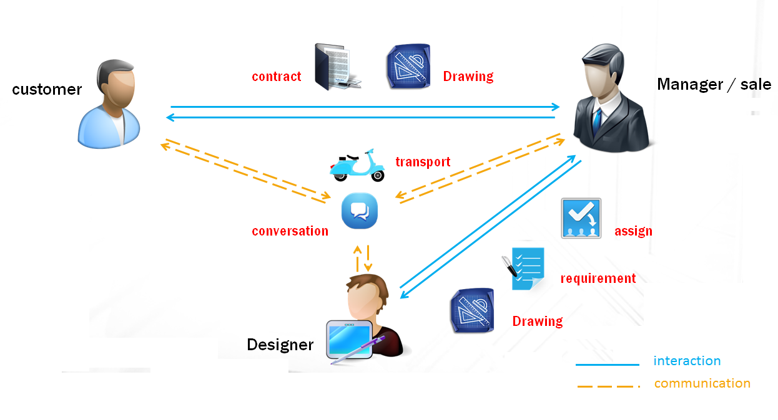

Figure 1. Current drawing request process

The figure 1 shows you the interaction in current decoration services between customer – manager/sale staff and designer.

First, we can see that, the communication of roles is transport and meeting for conversation. Customer finds a reliable architect company, and provides them information about his construction or decoration. The company’s employer will show them some templates or samples, and suggest them some trendy style.

If customer accepts the idea, he starts to make the contract; charge first payment and wait till the designer/architecture finish the raw drawing.

After review the raw drawing, he can changes what he dislikes and suggest what he likes. It repeats many times till the customer accepts, during this phase customer and staffs have few meeting, it’s such a waste of time and money. During the process, rarely the designer/architecture meet the customer for confirmation, all requirements are come from customer, to the manager/sale and then to the designer, and the designer give back the drawing following requirement that received from manager/sale.

## Problem Definition

Easily to see the two problem of current process is the cost of time and money for transport and the communication between customer and designer. The process may repeat many times depend on the customer accepts or not, so that when has any changes, customer or manager/sale must have a meeting, that may inconvenient to choose the right time for both.

One more problem is the customer must has some skill about read drawing to understand the draw, it hard for him to imagine what their house look like at final for make changes. That may cause misunderstand between customer – designer.

## Proposed Solution

### New Process

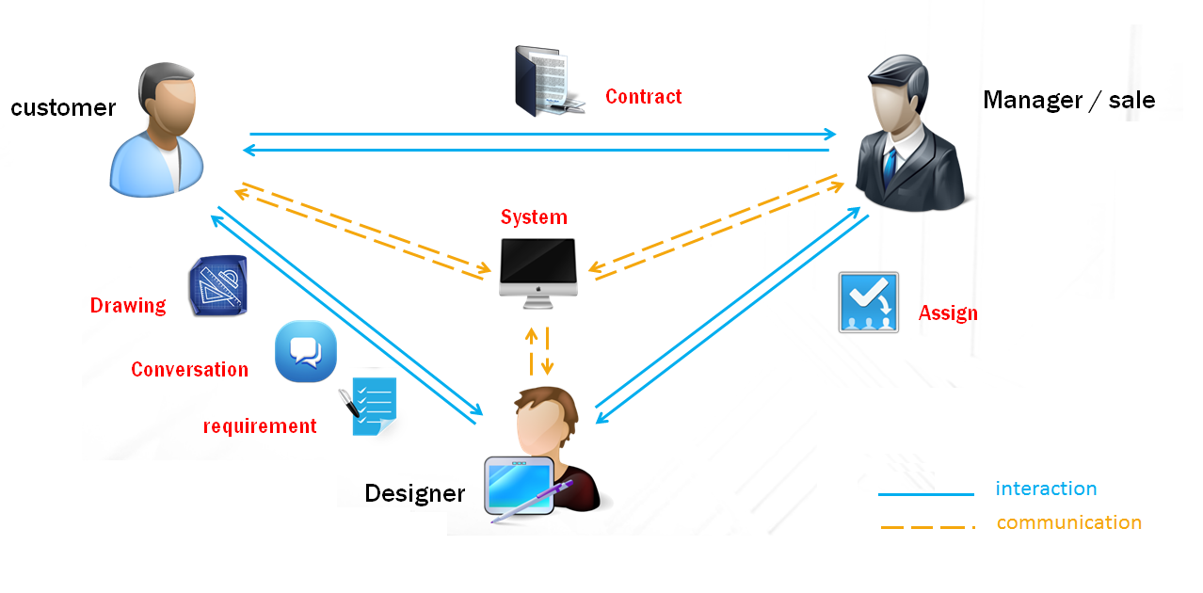

Figure 2. The RDCS's drawing request processing flow

The figure 2 describes how RDCS’s system run between 3 roles, and easily realizes that the main communication of process is not transport and conversation by meeting any more, they‘re replaced by RDCS’s system.

All positions play specific role, it’s separated for their profession and need of confirmation. The customer surfs RDCS’s system via internet and make new request, the manager/sale will read the request and decide to reject or approve the request, then assign to designer who available who will work with customer to make the drawing. During the processing, the designer will work with customer for requirement, any changes are communicate via reject/approve system. RDCS brings customer and designer closer, makes the requirement clearer. In other hand, any role just do their own job, does not need to have any other skill to communicate.

### Non-Financial

**Manager**:

* Track the customer’ request.
* Store and analysis survey
* Make and review contract.
* Manage payment and payment status.
* Support customer about contract and process.
* Accept and assign the request to designer.
* Confirm the payment and managed the payment

**Design**:

* Manage drawing.
* Design concepts, templates from gathered information of customer by Manager.
* Edit, change concept if has requested.
* Confirm the drawing.

**Customer:**

* Can request new drawing.
* Can view the current status of the request.
* Can be able to view design templates available on the system.
* Can view and modify the designer’s drawing in 3D.
* Can view all design drawing which made by them suggested by our service.
* Member of system can update their own profile.

**Guest**:

* Guest can view design drawing in gallery.
* Guest can register an account to become member of system.

**System**:

* Will notify customer when design drawing have completed by SMS, Email, or Phone.
* Will change the request’s status automatically.

### Financial

* Once the contract is accepted, the money will be charged via PayPal.
* When customer makes change, they need to charge money for changing.

## Functional Requirements

Functional requirements of the proposed system are listed by roles as below:

### Register

* Guest can register an account to become member of system.
* Member can be update profile.

### Explore Design Drawing

* Customers can explore Design Drawing by Template Category, range of fee.
* Detail page of Design Drawing include 3D Model, description of drawing.

### Contract Management

* This method only available for Manager and Administrator.
* Status of Contract can be change.
* After become a member of system, customer can request the system services.
* Update necessary information.
* Payment using PayPal.
* Customer make contract with Company.

### Template Management

* Designer and Administrator can create Template for Design Drawing.
* Template can be added to category by type, fee, or area.

### Filter – Suggestion

* Filter will show some suggesting Design Drawing according to information of customers include: hobbies, money, area, type of constructions.

### User – Customers Management

* Administrator can insert new user or customer.
* Administrator can ban the user or customer.
* Administrator can allocate user for Manager include Manager and Designer.

### Configuration management

* Admin can configuration the current price of drawing

### Request Management

* Manager can view/ filter all user’s request.
* Manager can view the current status of request.
* Manager can change the request status.

### Report Management

* Manager can make a report monthly, yearly.

# Software Project Management Plan

## Problem Definition

### Name of this capstone project

The Reliable Decoration and Construction Services (RDCS).

### Problem Abstract

During make a drawing, you can’t see your idea clearly and hard to imagine with 2D drawing , moreover you will go through many processes and once fail, you may repeat that step till you all accept, or in the worst case: find another company. It is a waste of time and money

### Project Overview

#### The current system

* The customer finds reliable Construction/Interior Decoration Company, provide their requirements.
* After give out information, the customer will be shownsome concept and customers’ successful designs for review and edit their own if they feel it necessary.
* Wait for the company analysis and give you their conceptual design drawing.
* If you agree, people start to talk about money, make a contract. But, if you are still not satisfied with the concept, you’ll keep going to the office for conversation and confirm the changes.
* The detailed design drawing will be made until the customer accepts the concept drawing.
* When receive the final drawing: you will face with some questions like ‘what will my house/roombe when it finishes?’, ‘is it look like my expected’, etc…. and it may causeby you find another company and repeat those steps above again, till get the drawing you want. Cost you a lot of money and time.
* After all, find a construction company and build your house with that drawing.

#### The proposed system

For solve that problems and improve customers ‘s vision, we made this project in order to provide people a convenient service that will helps them low-cost money and time. Customers, who use we service, will have an intuitive look of their design with 3D-drawing, no need to travel too much for confirm, easy to change, and when finish drawing we suggest for them list of reliable companies to bring it into reality.

* Access website and make a request.
* Manager will come and collect customer’s information, needs, talk about contract and any cost incurred (if has).
* Customer tracks their design and requests any changes till it is accepted.
* Service will build their 2D drawing to 3D view and send them email, SMS when complete for review.
* Suggest for customer some Construction/Interior Decoration Companies.

#### Development Environment

* + - 1. **Hardware requirement**

|  |  |  |
| --- | --- | --- |
|  | Minimum Requirements | Recommended |
| Internet Connection | Cable, Wifi (4 Mbps) | Cable, Wifi (8 Mbps) |
| Computer Processor | Intel® Core 2 Duo | Intel® Core(TM) i5 CPU , M 460 @ 2.53GHz |
| Computer Memory | 1GB RAM | 3GB or more |

* + - 1. **Software requirement**
* Operation system: Windows7 or Mac OSX 10.8 or Ubuntu10.10(or above)
* Apache Maven 3.04
* Apache Tomcat 7
* Apache Web Server 2.4 (Use for 3D framework)
* MySQL 5.4 (database management system)
* Google Chrome 31.0 (Test/debugs tool)
* IntelliJ IDEA 12.0.4 (IDE)
* TortoiseSVN 1.8.4 (Source code control)

## Project organization

### Software Process Model

Project is developed under agile model.

Agile model was introduced in 2001, and it was kind of a reformation of software engineering process since people could realize in an instance that this way of developing software is the most efficient and 'accurate' way to create something that people are willing to obtain.

Regarding software lifetimes, the Agile software lifecycle is so quick that new versions are available every two weeks, so they are not even special events as in the Waterfall or Spiral models.*- Patterson, David; Fox, Armando (2012-07-11)*

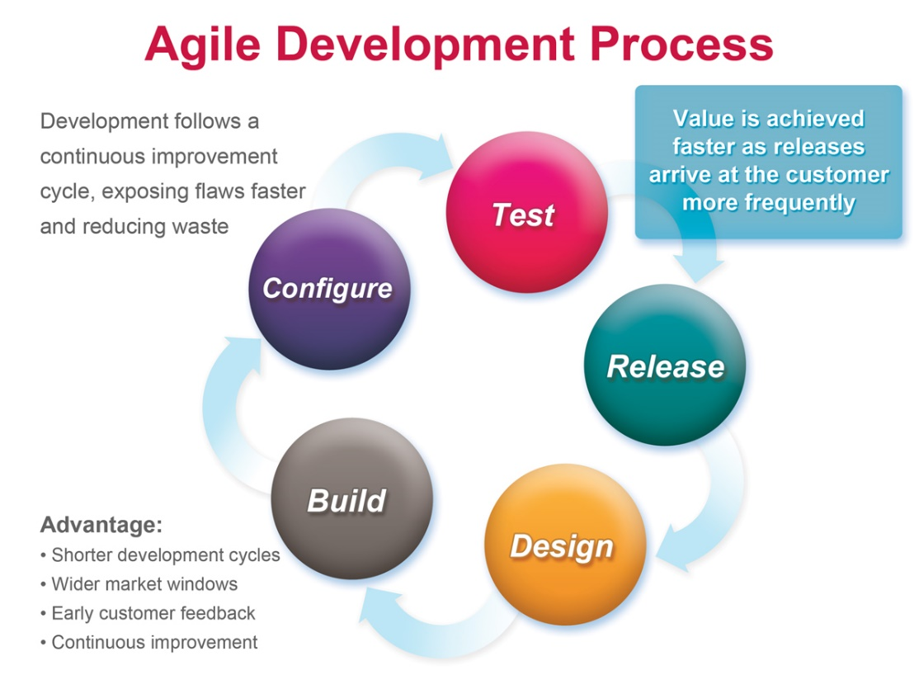

Figure 3. Agile model

### Role and responsibilities

|  |  |  |  |
| --- | --- | --- | --- |
| **No** | **Full name** | **Role in group** | **responsibilities** |
| 1 | Kiều Trọng Khánh | Project Manager | * Specify user requirement * Control the development process * Give out technique and business analysis support |
| 2 | Hà Minh Thanh | Team Leader | * Planning * Processes manage. * Coding * Testing * Document review |
| 3 | Nguyễn Huy Hưng | Team member | * GUI design * Coding * Testing * Prepare document |
| 4 | Phạm Ngọc Trầm | Team member | * Coding * Testing * Prepare document * Document review |
| 5 | Nguyễn Việt Hưng | Team member | * Coding * Testing * Prepare document |

### Tool and techniques

- Front-end technologies: HTML5, CSS3, JavaScript, jQuery 1.9.1, AJAX, BootTraps 3.

- Back-end: Restful WebService(Jersey 1.14), JPA 2.0 with EclipseLink, Java Mail API, Jersey 1.14

- Web Server: Apache Tomcat 7

- DBMS: MySQL 5.4

## Project management Plan

### Phrase/Iteration

|  |  |  |  |  |  |
| --- | --- | --- | --- | --- | --- |
| **Phrase**  **/Iteration** | **Description** | **Deliverables** | **Resource needed** | **Dependencies and Constrains** | **Risks** |
| **Preliminary Investigation or Analysis** | -Study similar existing systems.  -Identify and clarify requirement for the system in general.  -Study business + requirement of current system | -Introduction of proposed system.  -Main functions.  -Project Iteration Plan. | 30 man-days | N/A | Project may  not be feasible  for developing  because lack of technologies  and/or data |
| **Home page and Core service** | Implement core page and service of RDCS | Web app with core service | 70 man-days | N/A | Lack of experience. |
| **Construction Service** | Implement work flow for construction service | Web-app with construction service | 30 man-days | N/A | Lackofexperience. |
| **Decoration Service** | Implement work flow for decoration service | Web app with decoration service | 30 man-days | N/A | Lack of experience.  The implemented algorithm is not the best.  Lack of test data |

### Phrase/Iteration detail

#### Preliminary Investigation or Analysis

|  |  |  |
| --- | --- | --- |
| **Task** | **Description** | **Author** |
| 1. **Identifying and studying existing systems** | Find which systems currently provide similar service, their strengths and weakness. | ThanhHM, HungNH, TramPN |
| 1. **Identifying and clarifying main functions** | Define which main functions system should provide | ThanhHM, HungNH, TramPN |
| 1. **Create Plan/WBS** | Create project plan | ThanhHM |
| 1. **Create SRS** | Create Software requirements specification | ThanhHM, HungNH, TramPN |
| 1. **Create work flow** | Create business flow for this project | TramPN |
| 1. **Create SDD** | Create screen detailed design | HungNH |
| 1. **Create Prototype** | Create sample GUI | HungNH |
| 1. **Create report** | Create report follow cms plan | ThanhHM, HungNH, TramPN |
| 1. **Database design** | Design database follow work flow | ThanhHM |
| 1. **Review plan** | Review project plan | HungNH, TramPN |
| 1. **review report** | Review report | ThanhHM |
| 1. **Review prototype/SDD** | Review GUI design | ThanhHM |
| 1. **review SRS** | review Software requirements specification | ThanhHM |
| 1. **Complete prototype follow review feedback** | Update prototype, GUI after review | HungHN |
| 1. **Chooseframework/ Traning other member front-end framework** | Choose front-end framework like Bootstrap,etc.. | HungHN |
| 1. **Choose and configuration framework** | using Hibernate/Spring/Restful/JSP/etc… | ThanhHM |
| 1. **Create some base classes/packages** | Create code structures | ThanhHM |
| 1. **Understand and control Sweet Home framework** | need to control and understood well | TramPN |
| 1. **Demo to run framework on Web** | Can run on web and create/import/export template file | TramPN |

#### Home page and Core service

|  |  |  |
| --- | --- | --- |
| **Task** | **Description** | **Author** |
| * 1. **Identifying Requirement and Planning** | Which feature this function should have and how to implement. | ThanhHM,HungNH,TramPN |
| * 1. **Design/Implement home page** | The website should be beautiful as decoration service | HungNH |
| * 1. **User submit new request** | This function allow customer submit new request as decoration or construction design.  User can fill information as description, home’s information, etc.. | ThanhHM, HungNH |
| * 1. **User view list of processing request** | Allow customer to view all of processing request.  Order by last modified time.  The GUI should be clear and have tab for filtering | ThanhHM, HungNH |
| * 1. **User view list of history request** | Allow customer to view all of request (included DONE/CANCEL request).  Order by last modified time | ThanhHM, HungNH |
| * 1. **User can view status/ information of current request** | Allow customer to view the current information of request.  It should be useful information | HungNH |
| * 1. **Charge via PayPal** | Allow customer to pay via PayPal. | TramPN, HungNH |
| * 1. **View receipt after charge** | Can view receipt after charge | HungNH |
| * 1. **Confirm charged** | Allow manager to confirm that customer have charged directly | ThanhHM ,HungNH |
| * 1. **Connect to printer to print receipt** | Can connect directly to printer to print receipt | HungNH |
| * 1. **Upload file** | Allow user/designer can upload document/ 3D concept view to system | ThanhHM, HungNH |
| * 1. **System status automatically changed** | Allow system auto change status after event happened | ThanhHM, HungNH, TramPN |
| * 1. **Get list designer and Assigner designer to specified request** | Allow manager can search and select designer for specified request | ThanhHM, HungNH |
| * 1. **Designer view current request status** | Designer can view current request status | HungNH |
| * 1. **Manager can view current request status** | Manager can view current request status | HungNH |
| * 1. **SMS notification** | SMS notify to user when request state changed | ThanhHM |
| * 1. **Internal notification** | Internal notification alert when request state changed | ThanhHM |
| * 1. **Email notification** | When user register/create new request/ charged the Email notification should be sent | ThanhHM,HungHN |
| * 1. **View gallery template** | Allow customer to view gallery, view3D and create new request | TramPN |
| * 1. **Show Statistics of revenues** | Allow manager to view statistic of Revenues by Year/Month | TramPN |
| * 1. **Show statistics of customer trends** | Allow manager to view statistic of customer’s trends | TramPN |

#### Construction Service

|  |  |  |
| --- | --- | --- |
| **Task** | **Description** | **Author** |
| 1. **Identifying Requirement and Planning** | Which feature this function should have and how to implement. | ThanhHM, HungNH, TramPN |
| 1. **Business flow for construction service** | Verify business flow for construction service | HungNH, ThanhHM |
| 1. **Upload new template** | Allow designer can create and upload new template for suggestion | ThanhHM, HungNH |
| 1. **Choose suggestion template** | Allow designer to choice suggestion template | HungNH, ThanhHM |
| 1. **View 3D concept in website** | Allow customer/manager to view 3D concept on website | TramPN |
| 1. **Testing** | Test system behavior and performance Test user behavior and performance | HungHN, ThanhHM, TramPN |

#### Decoration Service

|  |  |  |
| --- | --- | --- |
| **Task** | **Description** | **Author** |
| **1. Identifying Requirement and Planning** | Which feature this function should have and how to implement. | ThanhHM, TramPN, HungNH |
| **2. Edit 3D concept in website** | Allow user/designer edit and save 3D concept on web-site | ThanhHM, TramPN, HungNH |
| **3. Testing** | Test system behavior and performance  Test user behavior and performance | HungHN, ThanhHM, TramPN |

### All Meeting Minutes

Refer to Meeting Minutes folder.

### Coding Convention

Follow Code Conventions for the Java TM Programming Language, by Sun Microsystems, rev April 20, 1999.

The below list outlines the standard Java naming conventions for each identifier type:

* **Packages:** Names should be in lowercase. With small projects that only have a few packages it's okay to just give them simple (but meaningful!) names:
* package pokeranalyzer

package mycalculator

In software companies and large projects where the packages might be imported into other classes, the names will normally be subdivided. Typically this will start with the company domain before being split into layers or features:

package com.mycompany.utilities

package org.bobscompany.application.userinterface

* **Classes:** Names should be in CamelCase. Try to use nouns because a class is normally representing something in the real world:
* class Customer

class Account

* **Interfaces:** Names should be in CamelCase. They tend to have a name that describes an operation that a class can do:
* interface Comparable

interface Enumerable

Note that some programmers like to distinguish interfaces by beginning the name with an "I":

interface IComparable

interface IEnumerable

* **Methods:** Names should be in mixed case. Use verbs to describe what the method does:
* void calculateTax()

string getSurname()

* **Variables:** Names should be in mixed case. The names should represent what the value of the variable represents:
* string firstName

int orderNumber

Only use very short names when the variables are short lived, such as in for loops:

for (int i=0; i<20;i++)

{

   //i only lives in here

}

* **Constants:** Names should be in uppercase.
* static final int DEFAULT_WIDTH

static final int MAX_HEIGHT

# Software Requirements Specification

## User Requirement Specification

### 1.1 Customer Requirement

▪Customer is authorized user of system, after logging to the system. A customer can do functions:

* Request Service.
* Upload File.
* Cancel Request.
* View request history.
* View request detail.
* View3D Drawing.
* Modify3D.
* View3D Template.
* Confirm: Approve, Reject.

### 1.2 Guest Requirement

▪Guest can do following functions:

* Register
* View 3D Template
* Login

### 1.3 Designer Requirement

▪Designer is an employee of company. Designer has an account which is allocated by admin. After login successful, Designer can do functions:

* Manage 3D Drawing
* Suggest Template
* Upload 3D Drawing
* Manage 3D Drawing

### 1.4 Manager Requirement

▪Manageris an employee of company. Manager has an account which is allocated by admin. After login successful, Managercan do functions:

* Statistic
* View Report
* Assign Designer
* Confirm: Approve, Reject.
* Manage Request.
* View Request History.
* View Request Detail.
* Payment Confirm.
* Contract Detail.
* Export: Print, Print Pdf.

### 1.5 Admin Requirement

### 1.6 System Requirement

▪System auto do following functions:

* Auto notify to customer when event was happened

## System Requirement Specification

### External Interface Requirements

#### 2.1.1 User Interfaces

* The interface of website is display in Vietnamese
* The notify messages must be short and easy to understand.

#### 2.1.2 Hardware Interfaces

* There is no extra hardware interfaces are needed. The system will use the standard hardware and data communications resources of a standard computer.

#### 2.1.3 Software Interfaces

* Browser support JavaScript and HTML5.

#### 2.1.4 Communications Protocol

* Website using HTTP protocol for communication between the web browser and the web server.

### System Overview Use Case

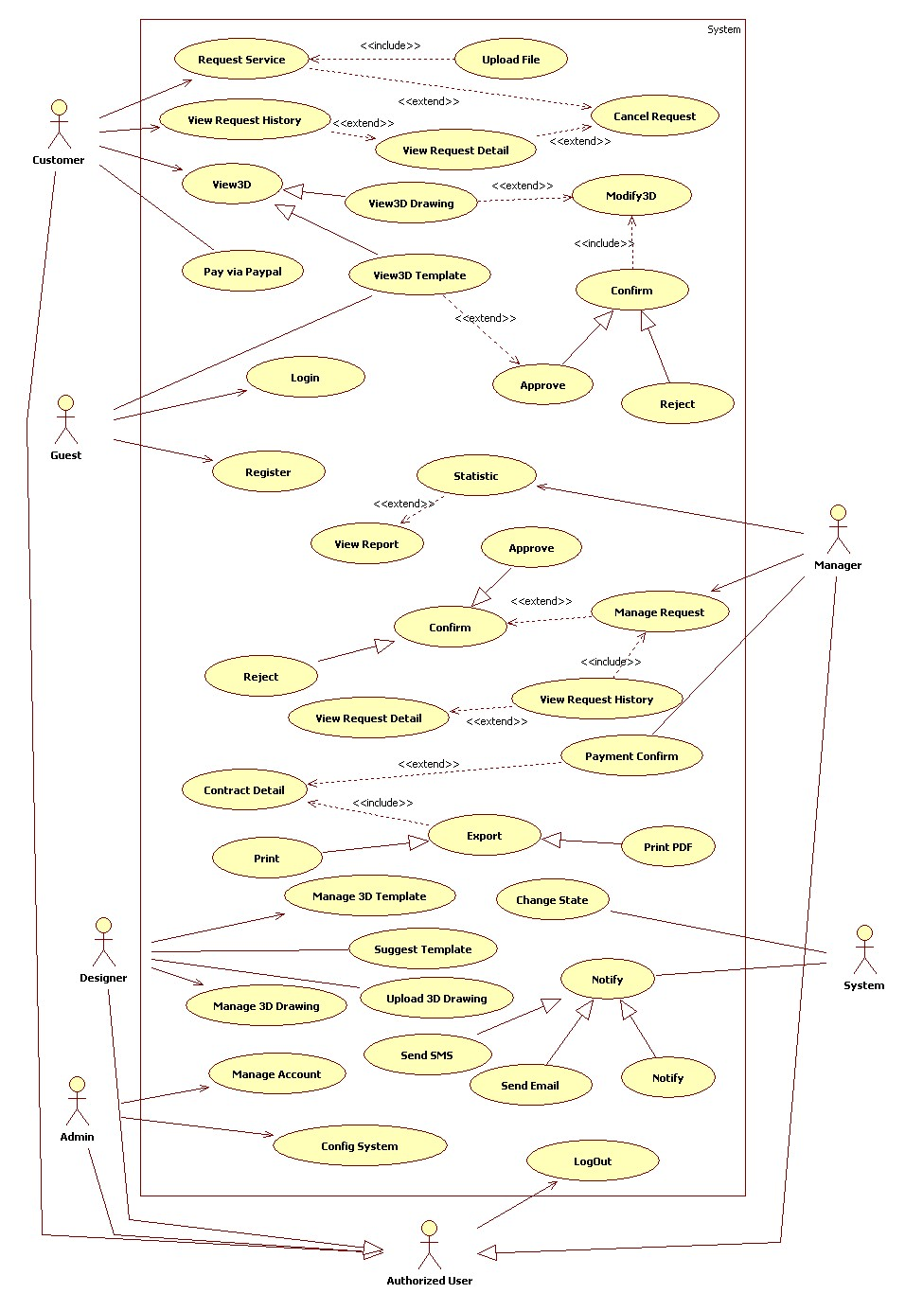

Figure 4. System overview Use Case

### List of Use Case

#### 2.3.1 <Customer>Overview Use Case

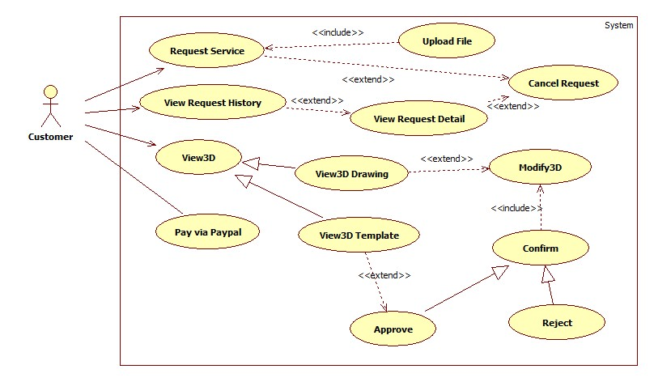

Figure 5. Customer Use Case

##### **2.3.1.1 <Customer>Request Service Use Case Diagram**

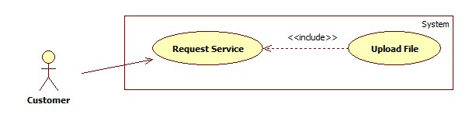

Figure 6. Customer request service Use Case

|  |  |  |  |  |  |  |  |  |
| --- | --- | --- | --- | --- | --- | --- | --- | --- |
| **USE CASE –CU001** | | | | | | | | |
| **Use Case No.** | | | CU001 | | **Use Case version** | | 2.0 | |
| **Use Case name** | | | Request Service | | | | | |
| **Author** | | | Phan Ngọc Trầm | | | | | |
| **Date** | | | 7/12/4/16/2014 | | **Priority** | Important | | |
| **Actor:**Customer  **Summary:**  Customer uses this case to make new service request.  **Goal:**  Customer add new request to system.  **Triggers:**  -          Customer wants to build or decorate their construction.  -          On the homepage, click on “CÁ NHÂN” menu on left side. Then click on “TẠO YÊU CẦU”  **Preconditions:**   * Customer make new service request.   **Post Conditions:**  -          **Success:**Customer’s document will be stored to system, transfer to “ĐANG XỬ LÝ” page.  -          **Fail:**Alert error.  **Main Success Scenario:** | | | | | | | | |
|  | Step | Actor Action | | System Response | | | |  |
| 1 | On Menu on the left side. Click “CÁ NHÂN”, then click New Request, | | -Popup insert new request will display, customer fill required information to this form:  + “Tiêu đề”: Title, Textbox, 50 characters  + “Mô tả”: Description, Textbox, 50 characters  + “Dài”: Length, Numeric, > 1.  + “Rộng”: Width, Numeric, > 1.  + “Số Tầng”: Floor, Numeric, > 1. | | | |
| 2 | Choose one of two option "Dịch vụ xây dựng nhà cửa” or “Dịch vụ trang trí nội thất”  [Alternative 1, 2] | |  | | | |
| 3 | - Click “Chọn Tập tin” button then choose customer’s document to upload | | - Open file dialog will display. | | | |
| 4 | Click “Gửi đi” button. | | - Transfer to “Đang Xử Lý” page. | | | |
| **Alternative Scenario:** | | | | | | |
| 1 | Click on “Dịch vụ xây dựng nhà cửa” | | - Customer requests Construction Service. | | | |
| 2 | Click on “Dịch vụ trang trí nội thất”. | | - Customer requests Decoration Service. | | | |
| **Exceptions:** | | | | | | |
| 1 | Not input to “Tiêu Đề” field. | | - Alert “Xin mời nhập tiêu đề”.<độ dài> | | | |
| 2 | Not input to “Mô tả” field. | | - Alert “Xin mời nhập mô tả”. | | | |
| 3 | Not input to “Dài” field. | | - Alert “Xin mời nhập chiều dài”. | | | |
| 4 | Not input to “Rộng” field. | | - Alert “Xin mời nhập chiều rộng”. | | | |
| 5 | Not input to “Số Tầng” field. | | - Alert “Xin mời nhập số tầng”. | | | |
| 6 | Not Upload document file | | - Alert “Xin mời Upload File”. | | | |
| **Relationships:**<Guest>Login, <Customer>Request Service  **Business Rules:**   * Customer upload construction document to system. * Only can upload picture type file. | | | | | | |

##### **2.3.1.2<Customer>RequestDetailUse Case Diagram**

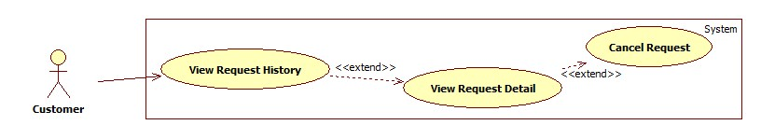

Figure 7. Customer View request detail Use Case

|  |  |  |  |  |  |  |  |  |
| --- | --- | --- | --- | --- | --- | --- | --- | --- |
| **USE CASE –CU002** | | | | | | | | |
| **Use Case No.** | | | CU002 | | **Use Case version** | | 2.0 | |
| **Use Case name** | | | View RequestDetail | | | | | |
| **Author** | | | Phan Ngọc Trầm | | | | | |
| **Date** | | | 07/12/2013 | | **Priority** | Important | | |
| **Actor:**Customer  **Summary:**  Customer used this case to view detail of their request.  **Goal:**  Customer view all detail information of their request.  **Triggers:**  -          After request new service, customer will review their request,  -          On the homepage, click on “CÁ NHÂN” menu on left side. Then click on “Đang Xử Lý”  **Preconditions:**   * At least one request has been DONE, or in proccessing.   **Post Conditions:**  -          **Success:**transfer to “Đang Xử Lý” page.  -          **Fail:**Alert error.  **Main Success Scenario:** | | | | | | | | |
|  | Step | Actor Action | | System Response | | | |  |
| 1 | On Menu on the left side. Click “CÁ NHÂN”, then click “Đang Xử Lý”, | | Transfer to “Đang Xử Lý” page, and list all their request haven’t done. | | | |
|  | **Relationships:**<Guest>Login, <Customer>Request Service,<Customer>Upload,  **Business Rules:**N/A | | | | | | |  |

##### **2.3.1.3<Customer>View3D Drawing Use Case Diagram**

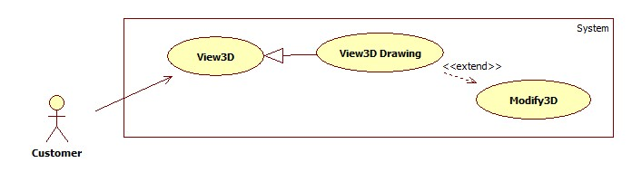

Figure 8. Customer view 3D Drawing Use Case

|  |  |  |  |  |  |  |  |  |
| --- | --- | --- | --- | --- | --- | --- | --- | --- |
| **USE CASE –CU003** | | | | | | | | |
| **Use Case No.** | | | CU003 | | **Use Case version** | | 2.0 | |
| **Use Case name** | | | View3D Drawing | | | | | |
| **Author** | | | Phan Ngọc Trầm | | | | | |
| **Date** | | | 07/12/2012 | | **Priority** | Important | | |
| **Actor:**Customer  **Summary:**  Customer uses this case to view construction drawing in 3D.  **Goal:**  Customer view their construction drawing in 3D.  **Triggers:**  -          Customer view construction drawing which has been drawed and uploaded by Designer in 3D  -          On the “Đang Xử Lý” page, click on Request’s waiting to review, then click on “Nhấp vào đây để xem bản vẽ 3D”.  **Preconditions:**   * Customer have been make new request and approved by manager * Designer draw and upload Drawing to system.   **Post Conditions:**  -          **Success:**transfer to preview3D page with 3D Drawing.  -          **Fail:**Alert error.  **Main Success Scenario:** | | | | | | | | |
|  | Step | Actor Action | | System Response | | | |  |
| 1 | On Menu on the left side. Click “CÁ NHÂN”, then click “Đang Xử Lý”, | | - Transfer to “Đang Xử Lý” page, and list all request. | | | |
|  | 2 | Click on request link | | - Request detail popup will be display, then click on “Nhấp vào đây để xem bản vẽ 3D”. | | | |  |
|  | **Alternative Scenario: N/A**  **Exceptions: N/A**  **Relationships:**<Guest>Login, <Customer>Request Service, <Manager>Assign <Designer>Upload,  **Business Rules:**   * Customer can only view one drawing, which has been upload by Designer. * Customer can Reject or Approve this 3D Drawing. | | | | | | |  |
|  |  | | | | | | |  |

##### **2.3.1.4<Customer>Request ServiceUse Case Diagram**



Figure 9. Customer modify 3D Drawing

|  |  |  |  |  |  |  |  |  |
| --- | --- | --- | --- | --- | --- | --- | --- | --- |
| **USE CASE –CU004** | | | | | | | | |
| **Use Case No.** | | | CU004 | | **Use Case version** | | 2.0 | |
| **Use Case name** | | | Modify 3D | | | | | |
| **Author** | | | Phan Ngọc Trầm | | | | | |
| **Date** | | | 07/12/2013 | | **Priority** | Important | | |
| **Actor:**Customer  **Summary:**  Customer uses this case to modify 3D decoration drawing.  **Goal:**  Customer will modify 3D decoration drawing to meet their favorite.  **Triggers:**  -          Customer view 3D decoration drawing which has been designed and uploaded by Designer.  -          On the “Đang Xử Lý” page, click on Request’s waiting to review, then click on “Nhấp vào đây để xem bản vẽ 3D”.  **Preconditions:** N/A  **Post Conditions:**  -          **Success:**transfer to Upload Page to upload document.  -          **Fail:**transfer to error page.  **Main Success Scenario:** | | | | | | | | |
|  | Step | Actor Action | | System Response | | | |  |
| 1 | On Menu on the left side. Click “CÁ NHÂN”, then click “Đang Xử Lý”, | | - Transfer to “Đang Xử Lý” page, and list all request. | | | |
|  | 2 | Click on request link | | - Request detail popup will be display, then click on “Nhấp vào đây để xem bản vẽ 3D”. | | | |  |
|  | **Relationships:**<Guest>Login, <Customer>Request Service, <Manager>Assign <Designer>Upload,  **Business Rules:**   * Customer can only view one drawing, which has been upload by Designer. * Customer can Modify or Approve this 3D Drawing. | | | | | | |  |

##### **2.3.1.5<Customer>Paypal Payment Use Case Diagram**

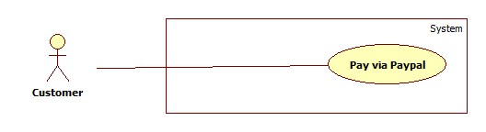

Figure 10. Customer Pay via Paypal use case

|  |  |  |  |  |  |  |  |  |
| --- | --- | --- | --- | --- | --- | --- | --- | --- |
| **USE CASE –CU005** | | | | | | | | |
| **Use Case No.** | | | CU005 | | **Use Case version** | | 2.0 | |
| **Use Case name** | | | Paypal Payment | | | | | |
| **Author** | | | Phan Ngọc Trầm | | | | | |
| **Date** | | | 07/12/2013 | | **Priority** | Important | | |
| **Actor:**Customer  **Summary:**  Customer uses this case to pay for their service.  **Goal:**  Customer pay for their service, which has been requested, via paypal.  **Triggers:**  -          Customer will make deposit to system for new request via paypal.  -          On the “Đang Xử Lý” page, click on request’s link, then click on “Thanh Toán”.  **Preconditions:**  **Post Conditions:**  -          **Success:**transfer to “Thanh Toánh Thành Công” page.  -          **Fail:**Alert Error.  **Main Success Scenario:** | | | | | | | | |
|  | Step | Actor Action | | System Response | | | |  |
| 1 | On Menu on the left side. Click “CÁ NHÂN”, then click “Đang Xử Lý”, | | - Transfer to “Đang Xử Lý” page, and list all request. | | | |
|  | 2 | Click on request link | | - Request detail popup will be display, then click on “Thanh Toán”. | | | |  |
|  | **Alternative Scenario: N/A**  **Exceptions: N/A**  **Relationships: :**<Guest>Login, <Customer>Request Service, <Manager>Assign, <Designer>Upload, <Customer> Approve  **Business Rules: N/A** | | | | | | |  |

##### **2.3.1.6<Customer> View RequestHistoryUse Case Diagram**



Figure 12. Customer view Request History Use Case

|  |  |  |  |  |  |  |  |  |
| --- | --- | --- | --- | --- | --- | --- | --- | --- |
| **USE CASE –CU006** | | | | | | | | |
| **Use Case No.** | | | CU006 | | **Use Case version** | | 2.0 | |
| **Use Case name** | | | Request History | | | | | |
| **Author** | | | Phan Ngọc Trầm | | | | | |
| **Date** | | | 07/12/2013 | | **Priority** | Important | | |
| **Actor:**Customer  **Summary:**   * Customer uses this case to view their request history.   **Goal:**   * Customer can view their request which had been finished.   **Triggers:**  -          After customer’s request change to “Done” state, it will be display in “Đã Hoàn Thành” page.  **Preconditions:**   * At least one request was changed to “DONE” state.   **Post Conditions:**  -          **Success:**transfer to “Đã Hoàn Thành” page.  -          **Fail:**Alert Error.  **Main Success Scenario:** | | | | | | | | |
|  | Step | Actor Action | | System Response | | | |  |
| 1 | On Menu on the left side. Click “CÁ NHÂN”, then click “Đã Hoàn Thành”, | | - Transfer to “Đang Xử Lý” page, and list all request. | | | |
|  | 2 | Click on request link. | | - Request detail popup will be display. | | | |  |
|  | **Alternative Scenario: N/A**  **Exceptions: N/A**  **Relationships: :**<Guest>Login, <Customer>Request Service, <Manager>Assign, <Designer>Upload, <Customer> Approve  **Business Rules: N/A** | | | | | | |  |

##### **2.3.1.7<Customer>Cancel RequestUse Case Diagram**



Figure 13. Customer Cancel Request Use Case

|  |  |  |  |  |  |  |  |  |
| --- | --- | --- | --- | --- | --- | --- | --- | --- |
| **USE CASE –CU007** | | | | | | | | |
| **Use Case No.** | | | CU007 | | **Use Case version** | | 2.0 | |
| **Use Case name** | | | Cancel Request | | | | | |
| **Author** | | | Phan Ngọc Trầm | | | | | |
| **Date** | | | 07/12/2013 | | **Priority** | Important | | |
| **Actor:**Customer  **Summary:**  Customer uses this case to cancel current request..  **Goal:**  Request service’s state will change to “DONE” state, and then it will be stopped.  **Triggers:**  - Customer wants to cancel current request.  - On Request detail click on “Hủy” button.  **Preconditions:**  **Post Conditions:**  -          **Success:**transfer to “Đang Xử Lý” page.  -          **Fail:**Alert Error.  **Main Success Scenario:** | | | | | | | | |
|  | Step | Actor Action | | System Response | | | |  |
| 1 | On Menu on the left side. Click “CÁ NHÂN”, then click “Đang Xử Lý”, | | - Transfer to “Đang Xử Lý” page, and list all request. | | | |
|  | 2 | Click on request link | | - Request detail popup will be display | | | |  |
|  | 3 | Click on “Hủy” button | | - Display confirm alert, then return back to “Đang Xử Lý” Page. | | | |  |
|  | **Alternative Scenario: N/A**  **Exceptions: N/A**  **Relationships: :**<Guest>Login, <Customer>Request Service, <Manager>Assign, <Designer>Upload, <Customer> Approve  **Business Rules:**   * Only request in “Đang Xử Lý” page can be Canceled. | | | | | | |  |

##### **2.3.1.8<Customer>Reject Use Case Diagram**

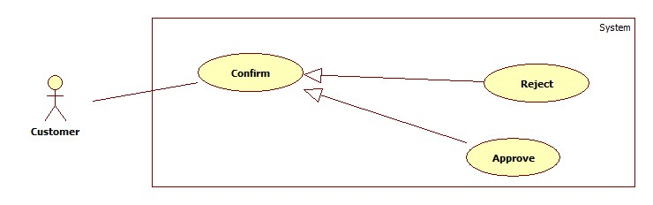

Figure 14. Customer Reject Drawing Use Case

|  |  |  |  |  |  |  |  |  |
| --- | --- | --- | --- | --- | --- | --- | --- | --- |
| **USE CASE –CU008** | | | | | | | | |
| **Use Case No.** | | | CU008 | | **Use Case version** | | 2.0 | |
| **Use Case name** | | | Reject | | | | | |
| **Author** | | | Phan Ngọc Trầm | | | | | |
| **Date** | | | 07/12/2013 | | **Priority** | Important | | |
| **Actor:**Customer  **Summary:**  Customer uses this case to reject 3D drawing.  **Goal:**  Customer reject 3D drawing..  **Triggers:**  - Designer creates 3D drawing, and uploaded it to system.  - Customer review and Reject it.  - On preview3D page, click on “Từ chối” button.  **Preconditions:**  **Post Conditions:**  -          **Success:**transfer to “Đang Xử Lý” page.  -          **Fail:**Alert Error.  **Main Success Scenario:** | | | | | | | | |
|  | Step | Actor Action | | System Response | | | |  |
| 1 | On Menu on the left side. Click “CÁ NHÂN”, then click “Đang Xử Lý”, | | - Transfer to “Đang Xử Lý” page, and list all request. | | | |
|  | 2 | Click on request link | | - Request detail popup will be display, then click on “Nhấp vào đây xem bản vẽ 3D”. | | | |  |
|  | 3 | Click on “ Từ chối” button. | | - Alert confirm, then return back to “Đang Xử Lý” page. | | | |  |
|  | **Alternative Scenario: N/A**  **Exceptions: N/A**  **Relationships: :**<Guest>Login, <Customer>Request Service, <Manager>Assign, <Designer>Upload, <Customer> Approve  **Business Rules:**N/A | | | | | | |  |

##### **2.3.1.9<Customer>Approve Use Case Diagram**



Figure 15. Customer Approve Drawing Use Case

|  |  |  |  |  |  |  |  |  |
| --- | --- | --- | --- | --- | --- | --- | --- | --- |
| **USE CASE –CU009** | | | | | | | | |
| **Use Case No.** | | | CU009 | | **Use Case version** | | 2.0 | |
| **Use Case name** | | | Approve | | | | | |
| **Author** | | | Phan Ngọc Trầm | | | | | |
| **Date** | | | 07/12/2013 | | **Priority** | Important | | |
| **Actor:**Customer  **Summary:**   * Customer uses this case to approve from Designer.   **Goal:**   * Customer review 3D template from Designer and approve it.   **Triggers:**  -          Designer create 3D drawing, and uploaded it to system.  - Customer review and Approve it.  - On preview3D page, click on “Đồng Ý” button.  **Preconditions:**  **Post Conditions:**  -          **Success:**transfer to “Đang Xử Lý” page.  -          **Fail:**Alert Error.  **Main Success Scenario:** | | | | | | | | |
|  | Step | Actor Action | | System Response | | | |  |
| 1 | On Menu on the left side. Click “CÁ NHÂN”, then click “Đang Xử Lý”, | | - Transfer to “Đang Xử Lý” page, and list all request. | | | |
|  | 2 | Click on request link | | - Request detail popup will be display, then click on “Nhấp vào đây xem bản vẽ 3D”. | | | |  |
|  | 3 | Click on “Đồng Ý” button. | | - Alert confirm, then return back to “Đang Xử Lý” page. | | | |  |
|  | **Alternative Scenario: N/A**  **Exceptions: N/A**  **Relationships: :**<Guest>Login, <Customer>Request Service, <Manager>Assign, <Designer>Upload, <Customer> Approve  **Business Rules: N/A** | | | | | | |  |

##### **2.3.1.10<Customer>View 3D Template Use Case Diagram**

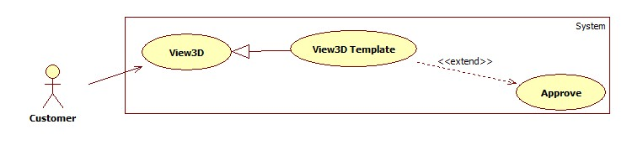

Figure 16 Customer View 3D template Use Case

|  |  |  |  |  |  |  |  |  |
| --- | --- | --- | --- | --- | --- | --- | --- | --- |
| **USE CASE –CU010** | | | | | | | | |
| **Use Case No.** | | | CU010 | | **Use Case version** | | 2.0 | |
| **Use Case name** | | | View3D Template | | | | | |
| **Author** | | | Phan Ngọc Trầm | | | | | |
| **Date** | | | 07/12/2013 | | **Priority** | Important | | |
| **Actor:**Customer  **Summary:**  This Use Case is used to view system’s 3D template.  **Goal:**  Customer can views sample 3D drawing of system and choose one for their favorite.  **Triggers:**  -          Guest want to view sample 3Dtemplate of system.  **Preconditions:** N/A  **Post Conditions:**  -          **Success:**transfer to galery page with all 3D Template.  -          **Fail:**Alert error  **Main Success Scenario:** | | | | | | | | |
|  | Step | Actor Action | | System Response | | | |  |
| 1 | On Left-side menu, click on “Galery” menu. | | Transfer to galery page, list all system’s 3D template. | | | |
|  | 2 | Click on 3D template thumnails. | | Transfer to view 3D page and show 3D template had been choose. | | | |  |
|  | **Alternative Scenario: N/A**  **Exceptions: N/A**  **Relationships: N/A**  **Business Rules:**   * Customer can view all 3D template of system. | | | | | | |  |

#### 2.3.2<Guest>Overview Use Case

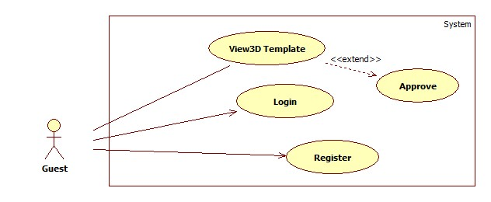

Figure 17 Guest Overview Use Case

##### **2.3.2.1 <Guest> Register Use Case Diagram**

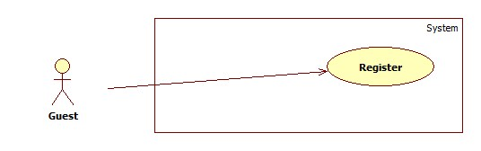

Figure 18. Guest register Use Case

|  |  |  |  |  |  |  |  |  |
| --- | --- | --- | --- | --- | --- | --- | --- | --- |
| **USE CASE –GU001** | | | | | | | | |
| **Use Case No.** | | | GU001 | | **Use Case version** | | 2.0 | |
| **Use Case name** | | | Register | | | | | |
| **Author** | | | Phan Ngọc Trầm | | | | | |
| **Date** | | | 07/12/2013 | | **Priority** | Normal | | |
| **Actor:**Guest  **Summary:**  Guest uses this case to become to a member of system.  **Goal:**  Guest’s require information will store on system.  **Triggers:**  -          Guest wants to request the services of system.  **Preconditions:** N/A  **Post Conditions:**  -          **Success:**transfer to Home page.  -          **Fail:**Alert error.  **Main Success Scenario:** | | | | | | | | |
|  | Step | Actor Action | | System Response | | | |  |
| 1 | On Top Rigth corner, click on “Đăng Ký” button. | | - “Đăng Ký Tài Khoản” page will be opened, guest have to fill to all required field:  + “Tên tài khoản”: User Account  + “Mật khẩu”: User Password  + “Nhập lại mật khẩu”: Confirm Password  + “Email”: Email  + “Tên của bạn”: Firstname  + “Họ của bạn”: Lastname  + “Địa chỉ”: Address  + “Số điện thoại”: Phone Number | | | |
| 2 | Click “Đăng Ký” button. | | - System Alert Register successful, then redirect to homepage. | | | |
| **Exceptions:** | | | | | | |
| 1 | Not input to “Tên tài khoản” field. | | - Alert “Xin mời nhập Tên tài khoản”. | | | |
| 2 | Not input to “Mật khẩu” field. | | - Alert “Xin mời nhập mật khẩu”. | | | |
| 3 | Not input to “Nhập lại mật khẩu” field. | | - Alert “Xin mời nhậplại mật khẩu”. | | | |
| 4 | Not input to “Email” field. | | - Alert “Xin mời nhập Email”. | | | |
| 5 | Not input to “Tên của bạn” field. | | - Alert “Xin mời nhập Tên của bạn”. | | | |
| 6 | Not input to “Họ của bạn” field. | | - Alert “Xin mời nhập Họ của bạn”. | | | |
| 7 | Not input to “Địa chỉ” field. | | - Alert “Xin mời nhập Địa chỉ”. | | | |
| 8 | Not input to “Số điện thoại” field. | | - Alert “Xin mời nhập Số điện thoại”. | | | |
| **Relationships: N/A**  **Business Rules:**   * Email have to be correct format. * “Mật Khẩu” fieldand “Nhập lại mật khẩu” field have to be same. * “Số điện thoại” have to cut the first zero number. | | | | | | |

##### **2.3.2.2 <Guest> Login Use Case Diagram**

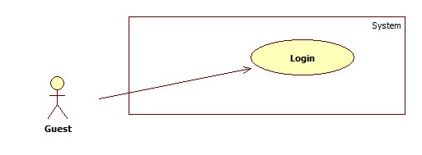

Figure 19 Guest Login Use Case

|  |  |  |  |  |  |  |  |  |
| --- | --- | --- | --- | --- | --- | --- | --- | --- |
| **USE CASE –GU001** | | | | | | | | |
| **Use Case No.** | | | GU002 | | **Use Case version** | | 2.0 | |
| **Use Case name** | | | Login | | | | | |
| **Author** | | | Phan Ngọc Trầm | | | | | |
| **Date** | | | 07/12/2013 | | **Priority** | Normal | | |
| **Actor:**Guest  **Summary:**  This Use Case is used to become a customer of system.  **Goal:**  Guest can use all function of system.  **Triggers:**  -          Guest want to become a customer of system  **Preconditions:** N/A  **Post Conditions:**  -          **Success:**transfer to Profile page.  -          **Fail:**Alert error.  **Main Success Scenario:** | | | | | | | | |
|  | Step | Actor Action | | System Response | | | |  |
| 1 | On Top Rigth corner,fill user to “Tài Khoản” filed and password to “Mật Khẩu” field, then  click on “Đăng Nhập” button. | | - Alert log in Successful, and redirect to profile page. | | | |
| **Relationships:**N/A  **Business Rules:**N/A | | | | | | |

##### **2.3.2.3<Guest> View 3D Template Use Case Diagram**

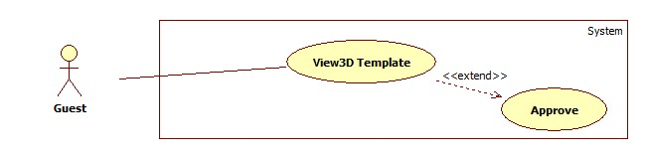

Figure 20. Guest View 3D template Use Case

|  |  |  |  |  |  |  |  |  |
| --- | --- | --- | --- | --- | --- | --- | --- | --- |
| **USE CASE –GU003** | | | | | | | | |
| **Use Case No.** | | | GU003 | | **Use Case version** | | 2.0 | |
| **Use Case name** | | | View3D Template | | | | | |
| **Author** | | | Phan Ngọc Trầm | | | | | |
| **Date** | | | 07/12/2013 | | **Priority** | Important | | |
| **Actor:**Guest  **Summary:**  This Use Case is used to view system’s 3D template.  **Goal:**  Customer can views sample 3D drawing of system and choose one for their favorite.  **Triggers:**  -          Guest want to view sample 3Dtemplate of system.  **Preconditions:** N/A  **Post Conditions:**  -          **Success:**transfer to gallery page with all 3D Template.  -          **Fail:**Alert error  **Main Success Scenario:** | | | | | | | | |
|  | Step | Actor Action | | System Response | | | |  |
| 1 | On Left-side menu, click on “Gallery” menu. | | Transfer to gallery page, list all system’s 3D template. | | | |
|  | 2 | Click on 3D template thumbnails. | | Transfer to view 3D page and show 3D template had been choose. | | | |  |
|  | **Alternative Scenario: N/A**  **Exceptions: N/A**  **Relationships: N/A**  **Business Rules:**   * Guest can view all 3D template of system. | | | | | | |  |

#### 2.3.3<System>Overview Use Case

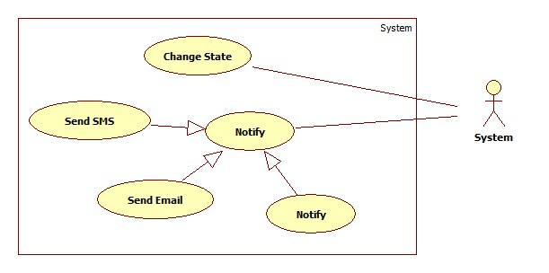

Figure 21. System overview Use Case

##### **2.3.3.1 <System> Email Use Case Diagram**

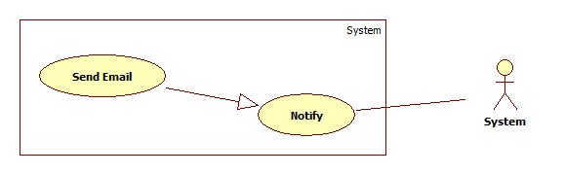

Figure 22 System Email Use Case

|  |  |  |  |  |
| --- | --- | --- | --- | --- |
| **USE CASE –SU001** | | | | |
| **Use Case No.** | SU001 | **Use Case version** | | 2.0 |
| **Use Case name** | Send Email | | | |
| **Author** | Phan Ngọc Trầm | | | |
| **Date** | 07/12/201 | **Priority** | Normal | |
| **Actor:**System  **Summary:**  - System auto email to customer when meet important event.  **Goal:**  - System auto email to customer when meet important event.  **Triggers:**  - System auto email to customer when meet important event.  **Preconditions:** N/A  **Post Conditions: N/A**  **Relationships: N/A**  **Business Rules:** N/A | | | | |

##### **2.3.3.2 <System>Send SMSUse Case Diagram**

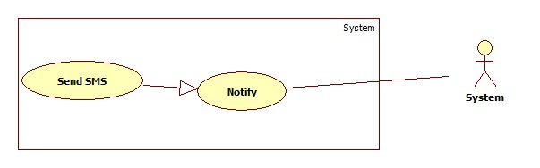

Figure 23 SMS Use case diagram

|  |  |  |  |  |
| --- | --- | --- | --- | --- |
| **USE CASE –SU002** | | | | |
| **Use Case No.** | SU002 | **Use Case version** | | 2.0 |
| **Use Case name** | Send SMS | | | |
| **Author** | Phan Ngọc Trầm | | | |
| **Date** | 07/12/2013 | **Priority** | Normal | |
| **Actor:**System  **Summary:**  - System auto SMS to customer when meet important event.  **Goal:**  - System auto SMS to customer when meet important event.  **Triggers:**  - System auto SMS to customer when meet important event.  **Preconditions:** N/A  **Post Conditions: N/A**  **Relationships: N/A**  **Business Rules:** N/A | | | | |

##### **2.3.3.3<System>NotificationUse Case Diagram**

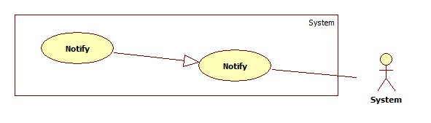

Figure 24 Notification Use Case

|  |  |  |  |  |
| --- | --- | --- | --- | --- |
| **USE CASE –SU003** | | | | |
| **Use Case No.** | SU003 | **Use Case version** | | 2.0 |
| **Use Case name** | Notification | | | |
| **Author** | Phan Ngọc Trầm | | | |
| **Date** | 07/12/2013 | **Priority** | Normal | |
| **Actor:**System  **Summary:**  - System auto Notification to customer when meet important event.  **Goal:**  - System auto Notification to customer when meet important event.  **Triggers:**  - System auto Notification to customer when meet important event.  **Preconditions:** N/A  **Post Conditions: N/A**  **Relationships: N/A**  **Business Rules:** N/A | | | | |

##### **2.3.3.3<System>Change Request State Use Case Diagram**

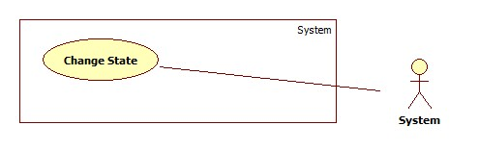

Figure 25. Change Request State Use Case

|  |  |  |  |  |
| --- | --- | --- | --- | --- |
| **USE CASE –SU004** | | | | |
| **Use Case No.** | SU004 | **Use Case version** | | 2.0 |
| **Use Case name** | Change State | | | |
| **Author** | Phan Ngọc Trầm | | | |
| **Date** | 07/12/2013 | **Priority** | Normal | |
| **Actor:**System  **Summary:**  - System auto change Request’s Statewhen event occur.  **Goal:**  - System auto change Request’s Statewhen event occur.  **Triggers:**  - System auto change Request’s Statewhen event occur.  **Preconditions:** N/A  **Post Conditions: N/A**  **Relationships: N/A**  **Business Rules:** N/A | | | | |

#### 2.3.4<Designer>Overview Use Case

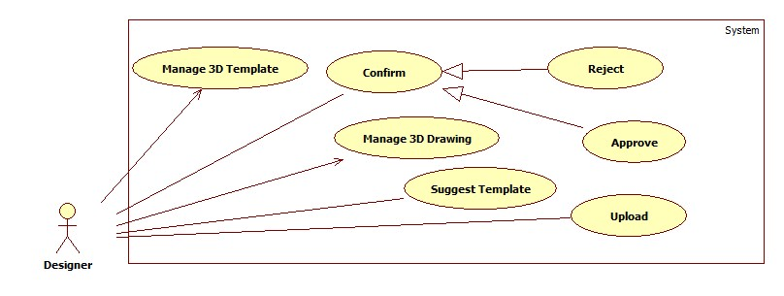

Figure 26. Designer Overview Use Case

##### **2.3.4.1 <Designer>Upload 3D Drawing Use Case Diagram**

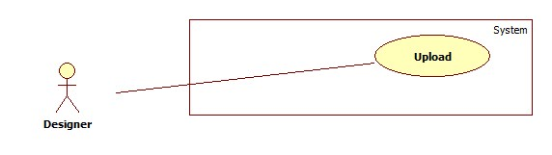

Figure 27. Designer Upload 3D Drawing

|  |  |  |  |  |  |  |  |  |
| --- | --- | --- | --- | --- | --- | --- | --- | --- |
| **USE CASE –DU001** | | | | | | | | |
| **Use Case No.** | | | DU001 | | **Use Case version** | | 2.0 | |
| **Use Case name** | | | Upload | | | | | |
| **Author** | | | Phan Ngọc Trầm | | | | | |
| **Date** | | | 07/12/2013 | | **Priority** | Important | | |
| **Actor:**Designer  **Summary:**   * Designer uploads 3D drawing to system.   **Goal:**   * 3D drawing will be uploaded and store in system,then customer can review it. .   **Triggers:**  -          After create 3D Drawing, Designer upload their drawing to system.  -          On the main page, click on request link and click “Upload” button.  **Preconditions:**  **Post Conditions:**  -          **Success:**transfer to main page  -          **Fail:**Alert error  **Main Success Scenario:** | | | | | | | | |
|  | Step | Actor Action | | System Response | | | |  |
| 1 | On Main page, click on Request link. | | - Popup request detail will be displayed. | | | |
| 2 | Click on “Chọn tập tin” button. | | - Select file window will be showed. | | | |
| 3 | Choose 3D Drawing file then click ok, and click Upload button | | - Return request detail popup. | | | |
| 4 | Click “Xác Nhận” button | | - Return to designer main page. | | | |
| **Relationships: N/A**  **Business Rules:**   * Only one 3D drawing can be uploaded. * Customer can review this 3D drawing file. | | | | | | |

##### **2.3.4.2 <Designer> Suggestion Use Case Diagram**

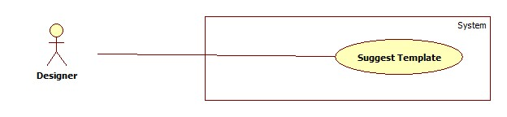

Figure 28 Designer Suggest template Use Case

|  |  |  |  |  |  |  |  |  |
| --- | --- | --- | --- | --- | --- | --- | --- | --- |
| **USE CASE –DU002** | | | | | | | | |
| **Use Case No.** | | | DU002 | | **Use Case version** | | 2.0 | |
| **Use Case name** | | | Suggestion | | | | | |
| **Author** | | | Phan Ngọc Trầm | | | | | |
| **Date** | | | 07/12/2013 | | **Priority** | Normal | | |
| **Actor:**Designer  **Summary:**   * Designer use this case to recommend template for customer   **Goal:**   * Customer will have more option can be choose to do final Drawing.   **Triggers:**   * Customer make new request, then Designer recommend template for customer   **Preconditions:** N/A  **Post Conditions:**  -          **Success:**Template info display in request detail.  -          **Fail:**Alert error.  **Main Success Scenario:** | | | | | | | | |
|  | Step | Actor Action | | System Response | | | |  |
| 1 | On Designer Main page, click on request link | | - Display Request detail popup. | | | |
| 2 | Fill name of template in “Template” fill, then click to template | | - Display template and it’s information on right side of popup | | | |
| **Relationships: N/A**  **Business Rules: N/A** | | | | | | |

##### **2.3.4.3<Designer>ApproveUse Case Diagram**

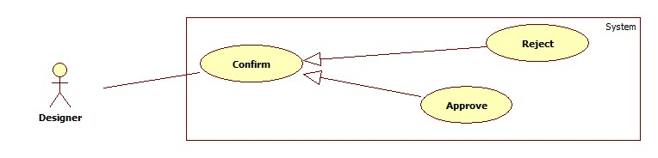

Figure 29 Designer Approve Customer Modification

|  |  |  |  |  |  |  |  |  |
| --- | --- | --- | --- | --- | --- | --- | --- | --- |
| **USE CASE –DU003** | | | | | | | | |
| **Use Case No.** | | | DU003 | | **Use Case version** | | 2.0 | |
| **Use Case name** | | | Approve | | | | | |
| **Author** | | | Phan Ngọc Trầm | | | | | |
| **Date** | | | 07/12/2013 | | **Priority** | Normal | | |
| **Actor:**Designer  **Summary:**   * Designer approve modified 3D decoration drawing.   **Goal:**   * Approve decoration 3D drawing, which had been modified by customer.   **Triggers:**   * Customer modified decoration 3D drawing, then send back to system, Designer receive customer’s modified 3D drawing then approve it   **Preconditions:** N/A  **Post Conditions:**  -          **Success:**Request change state to Approved  -          **Fail:**Alert error.  **Main Success Scenario:** | | | | | | | | |
|  | Step | Actor Action | | System Response | | | |  |
| 1 | On Designer Main page, click on request link | | - Display Request detail popup. | | | |
| 2 | Click on “Xem bản vẽ Khách hàng chỉnh sửa” | | - Open view3D page, and load modified 3D drawing. | | | |
| 3 | Click “Chấp Nhận” button | | - Alert successful and close page. | | | |
| **Relationships: N/A**  **Business Rules: N/A** | | | | | | |

##### **2.3.4.4<Designer> Reject Use Case Diagram**



Figure 30 Designer Reject Customer's Modification

|  |  |  |  |  |  |  |  |  |
| --- | --- | --- | --- | --- | --- | --- | --- | --- |
| **USE CASE –DU004** | | | | | | | | |
| **Use Case No.** | | | DU004 | | **Use Case version** | | 2.0 | |
| **Use Case name** | | | Reject | | | | | |
| **Author** | | | Phan Ngọc Trầm | | | | | |
| **Date** | | | 07/12/2013 | | **Priority** | Normal | | |
| **Actor:**Designer  **Summary:**   * Designer reject modified 3D decoration drawing.   **Goal:**   * Reject decoration 3D drawing, which had been modified by customer.   **Triggers:**   * Customer modified decoration 3D drawing, then send back to system, Designer receive customer’s modified 3D drawing then reject it.   **Preconditions:** N/A  **Post Conditions:**  -          **Success:**Request change State to …  -          **Fail:**Alert error.  **Main Success Scenario:** | | | | | | | | |
|  | Step | Actor Action | | System Response | | | |  |
| 1 | On Designer Main page, click on request link | | - Display Request detail popup. | | | |
| 2 | Click on “Xem bản vẽ Khách hàng chỉnh sửa” | | - Open view3D page, and load modified 3D drawing. | | | |
| 3 | Click “Từ Chối” button | | - Alert successful and close page. | | | |
| **Relationships: N/A**  **Business Rules: N/A** | | | | | | |

#### 2.3.5<Manager>Overview Use Case

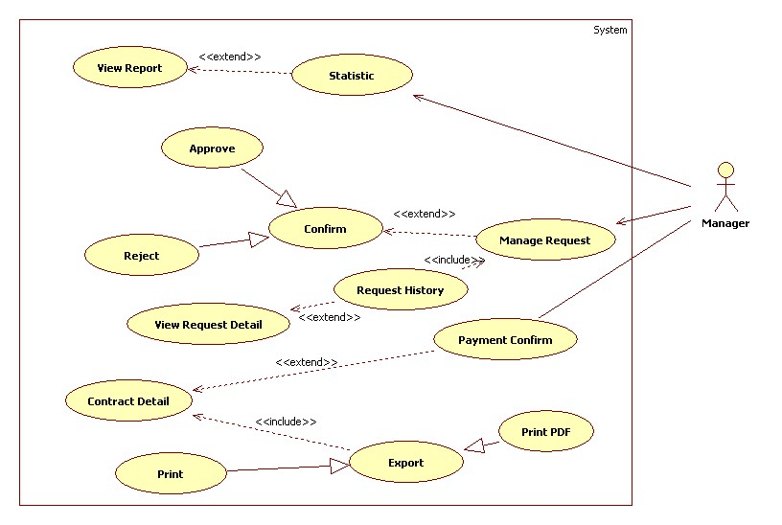

Figure 31. Manager Overview Use Case

##### **2.3.5.1 <Manager>Statistic Use Case Diagram**

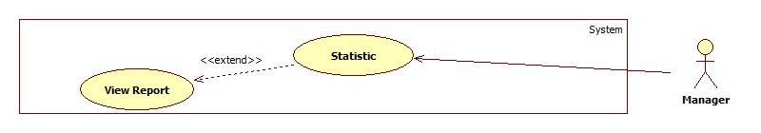

Figure 32. Manager View Statistic Use Case

|  |  |  |  |  |  |  |  |  |
| --- | --- | --- | --- | --- | --- | --- | --- | --- |
| **USE CASE –MU001** | | | | | | | | |
| **Use Case No.** | | | MU001 | | **Use Case version** | | 2.0 | |
| **Use Case name** | | | Statistic | | | | | |
| **Author** | | | Phan Ngọc Trầm | | | | | |
| **Date** | | | 07/12/2013 | | **Priority** | Normal | | |
| **Actor:**Manager  **Summary:**   * Statistic turnover of system.   **Goal:**   * Manager can manage turnover of system.   **Triggers:**   * System active in time, manager want to tracking turnover of system in yearly, monthly.   **Preconditions:** N/A  **Post Conditions:**  -          **Success:**  -          **Fail:**  **Main Success Scenario:** | | | | | | | | |
|  | Step | Actor Action | | System Response | | | |  |
| 1 | On Manager main page, click on “Report” Button, | | -Open report page and show turnover charts. | | | |
| **Relationships: N/A**  **Business Rules:**   * Report turnover monthly, yearly | | | | | | |

##### **2.3.5.2<Manager>Approve Use Case Diagram**

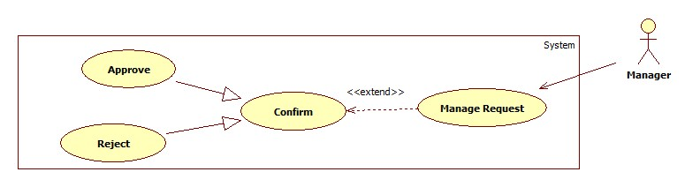

Figure 34. Manager Approve the Request

|  |  |  |  |  |  |  |  |  |
| --- | --- | --- | --- | --- | --- | --- | --- | --- |
| **USE CASE MU003** | | | | | | | | |
| **Use Case No.** | | | MU003 | | **Use Case version** | | 2.0 | |
| **Use Case name** | | | Approve | | | | | |
| **Author** | | | Phan Ngọc Trầm | | | | | |
| **Date** | | | 07/12/2013 | | **Priority** | Normal | | |
| **Actor:**Manager  **Summary:**   * Manager approve customer’s service request.   **Goal:**   * Customer’s service request will be approved.   **Triggers:**   * Customer make new service request. * Manager review and approve it.   **Preconditions:** N/A  **Post Conditions:**  -          **Success:**Return manager main page.  -          **Fail:**Alert error.  **Main Success Scenario:** | | | | | | | | |
|  | Step | Actor Action | | System Response | | | |  |
| 1 | On Manager Main page, click on request link | | - Display Request detail popup. | | | |
| 2 | Click “Xác Nhận” button | | - Return Manager page. | | | |
| **Relationships: N/A**  **Business Rules: N/A** | | | | | | |

##### **2.3.5.3<Manager>Approve Use Case Diagram**



Figure 35. Manager Reject Request

|  |  |  |  |  |  |  |  |  |
| --- | --- | --- | --- | --- | --- | --- | --- | --- |
| **USE CASE MU004** | | | | | | | | |
| **Use Case No.** | | | MU004 | | **Use Case version** | | 2.0 | |
| **Use Case name** | | | Reject | | | | | |
| **Author** | | | Phan Ngọc Trầm | | | | | |
| **Date** | | | 07/12/2013 | | **Priority** | Normal | | |
| **Actor:**Manager  **Summary:**   * Manager reject customer’s service request.   **Goal:**   * Customer’s service request will be rejected.   **Triggers:**   * Customer make new service request. * Manager review and reject it.   **Preconditions:** N/A  **Post Conditions:**  -          **Success:**Return manager main page.  -          **Fail:**Alert error.  **Main Success Scenario:** | | | | | | | | |
|  | Step | Actor Action | | System Response | | | |  |
| 1 | On Manager Main page, click on request link | | - Display Request detail popup. | | | |
| 2 | Click “Từ Chối” button | | - Return Manager page. | | | |
| **Relationships: N/A**  **Business Rules: N/A** | | | | | | |

##### **2.3.5.4<Manager>Request History Use Case Diagram**

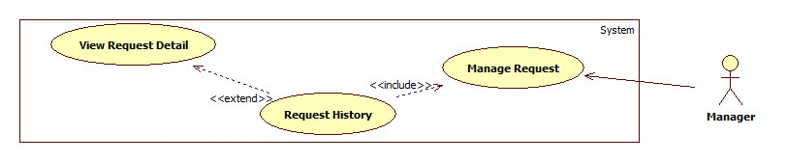

Figure 36 Manager View Request History

|  |  |  |  |  |
| --- | --- | --- | --- | --- |
| **USE CASE –MU005** | | | | |
| **Use Case No.** | MU005 | **Use Case version** | | 2.0 |
| **Use Case name** | Request History | | | |
| **Author** | Phan Ngọc Trầm | | | |
| **Date** | 07/12/2013 | **Priority** | Normal | |
| **Actor:**Manager  **Summary:**   * Tracking all customer’s request.   **Goal:**   * Manager can tracking all customer’s request   **Triggers:**  **Preconditions:** N/A  **Post Conditions:**  -          **Success:**  -          **Fail:**  **Relationships: N/A**  **Business Rules: N/A** | | | | |

##### **2.3.5.5<Manager>Payment Confirm Use Case Diagram**

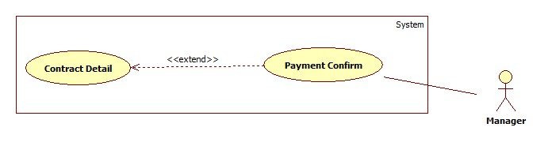

Figure 37. Manager Confirm Payment Use Case

|  |  |  |  |  |  |  |  |  |
| --- | --- | --- | --- | --- | --- | --- | --- | --- |
| **USE CASE –MU006** | | | | | | | | |
| **Use Case No.** | | | MU006 | | **Use Case version** | | 2.0 | |
| **Use Case name** | | | Payment Confirm | | | | | |
| **Author** | | | Phan Ngọc Trầm | | | | | |
| **Date** | | | 07/12/2013 | | **Priority** | Normal | | |
| **Actor:**Manager  **Summary:**   * Confirm directed payment of customer.   **Goal:**   * Manager confirm customer’s directed payment at system’s official   **Triggers:**  - When customer pay by cash or make payment directly at system official  - Manager will confirm that payment.  **Preconditions:** N/A  **Post Conditions:**  -          **Success:**transfer to Request History page.  -          **Fail:**transfer to error page.  **Main Success Scenario:** | | | | | | | | |
|  | Step | Actor Action | | System Response | | | |  |
| 1 | On Manager Main page, click on request link | | - Display Request detail popup. | | | |
| 2 | Click “Xác Nhận thanh toán” button | | - Popup description will be displayed. | | | |
| 3 | Click on “Xác nhận” button. | | - Return back to Manager page. | | | |
| **Relationships: N/A**  **Business Rules: N/A** | | | | | | |

#### 2.3.6<Admin>Overview Use Case

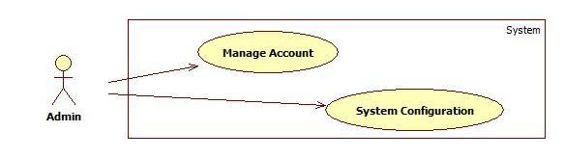

Figure 38 Admin Overview Use Case

#### 2.3.7<Authorized User>Overview Use Case

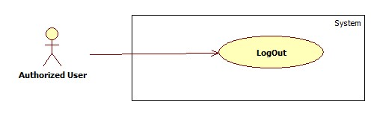

Figure 39 Authorized User Overview Use Case

##### **2.3.7.1 <Authorized User> LogoutUse Case Diagram**



Figure 40. Authorized User Logout Use Case

|  |  |  |  |  |  |  |  |  |
| --- | --- | --- | --- | --- | --- | --- | --- | --- |
| **USE CASE –AUU001** | | | | | | | | |
| **Use Case No.** | | | AUU001 | | **Use Case version** | | 2.0 | |
| **Use Case name** | | | LogOut | | | | | |
| **Author** | | |  | | | | | |
| **Date** | | |  | | **Priority** | Normal | | |
| **Actor:**Authorized User  **Summary:**   * Authorized User use this case to sign out the system.   **Goal:**   * Authorized User use this case to sign out the system.   **Triggers:**  -          Authorized User use this case to sign out the system  **Preconditions:** N/A  **Post Conditions:**  -          **Success:**  -          **Fail:**  **Main Success Scenario:** | | | | | | | | |
|  | Step | Actor Action | | System Response | | | |  |
| 1 | On Top – right corner of page, click on “Thoát” button | | - Return to Homepage. | | | |
| **Relationships: N/A**  **Business Rules: N/A** | | | | | | |

## Software System Attribute

### 3.1 Usability

##### **3.1.1 Graphic User Interface**

* All the text, label and image in public user page, and manager page should be in Vietnamese.

##### **3.1.2 Usability for guest**

* Can use some public function without login.

##### **3.1.3 Usability for Manager**

* Website admin and Manager should need less than one week of training to be productive with the system.

##### **3.1.4 Installation**

* The system must be easy to deploy. Customer can deploy successfully and learn to configure, maintain the system within one day of training.
* The attached manual guide must be clear. User can read and do themselves without developer’s help.

### 3.2 Reliability

* Accurate: 99%

### 3.3 Availability

* N/A

### 3.4 Security

* Privacy: Each role of user has a specific permission to interact with system.
* System always checks authorization and authenticated before do anything.
* Only admin can grant permission to Manager.

### 3.5 Maintainability

- N/A

### 3.6 Portability

- N/A

### 3.7 Performance

- N/A

## Conceptual Diagram

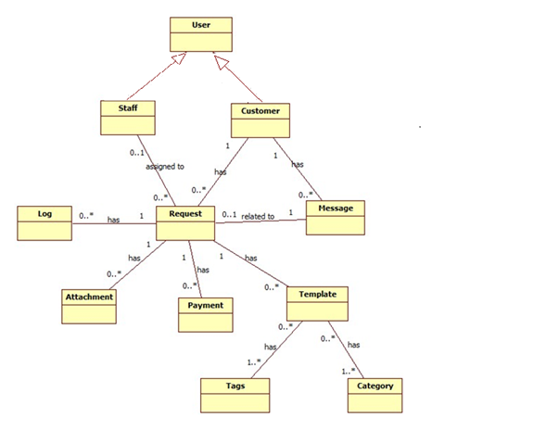

Figure 41 Conceptual Diagram

|  |  |  |
| --- | --- | --- |
|  | **Concepts** | **Description** |
| 1 | Staff | Staff of system: Include Designer and Manager |
| 2 | Customer | The customer use RDCS system |
| 3 | Log | The log is use for RDCS system. It use for logging customer and staff action |
| 4 | Request | The request of customer (Decoration and Construction) |
| 5 | Message | The message for user |
| 6 | Attachment | The attachment of the request |
| 7 | Template | The 3D template use in gallery and suggestion |
| 8 | Tag | The tags of template |
| 9 | Category | The category of template |
| 10 | Payment | The payment for the request |

# Software Design Description

## Design Overview

* This document describes the technical and user interface design of the RDCS system. It includes the architectural design, the detailed design of common functions and business functions and the design of database model.
* The architectural design describes the overall architecture of the system and the architecture of each main component and subsystem.
* The detailed design describes static and dynamic structure for each component and functions. It includes class diagrams, class explanations and sequence diagrams for each use cases.
* The database design describes the relationships between entities and details of each entity.
* Document overview:
* Section 2: gives an overall description of the system architecture design.
* Section 3: gives component diagrams that describe the connection and integration of the system.
* Section 4: gives the detail design descriptions include class diagram, class explanation, and sequence diagram to details the application functions.
* Section 5: describe an ERD with logical diagram

## System Architectural Design

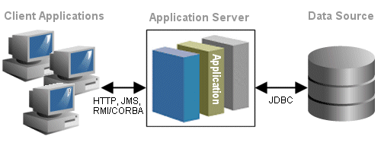

Figure 42 The three tiers software architecture

(http://java.boot.by/scea5-guide/ch02s02.html)

The three tier architecture is used when an effective distributed client/server design is needed that provides (when compared to the two tier) increased performance, flexibility, maintainability, reusability, and scalability, while hiding the complexity of distributed processing from the user.

* A three tier distributed client/server architecture includes a user system interface top tier where user services (such as session, text input, dialog, and display management) reside.
* The third tier provides database management functionality and is dedicated to data and file services that can be optimized without using any proprietary database management system languages. The data management component ensures that the data is consistent throughout the distributed environment through the use of features such as data locking, consistency, and replication. It should be noted that connectivity between tiers can be dynamically changed depending upon the user's request for data and services.
* The middle tier provides process management services (such as process development, process enactment, process monitoring, and process resourcing) that are shared by multiple applications.

## Component diagram

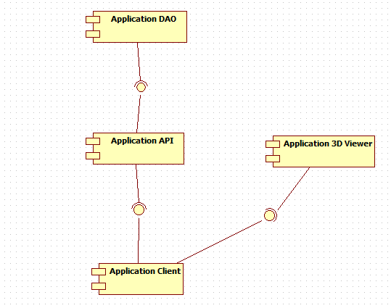

Figure 43 Component Diagram

|  |  |  |
| --- | --- | --- |
|  | **Component name** | **Component description** |
| 1 | Application Client | The component is as front-end part. It use for display in client side |
| 2 | Application API | The component is a component for RDCS business |
| 3 | Application 3D Viewer | The component for 3D viewer/editable part. |
| 4 | Application DAO | The component use to access database |

## Detailed Description of Components

## Class diagram

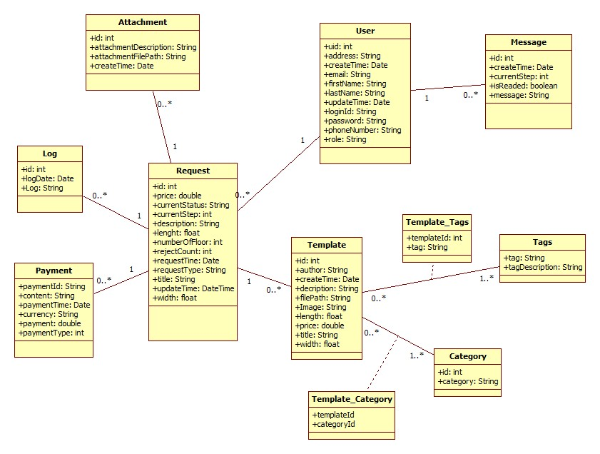

Figure 44 Class diagram

## Class Diagram Explanation

* + 1. **Request**

|  |  |  |  |
| --- | --- | --- | --- |
| **Attribute** | **Type** | **Visibility** | **Description** |
| Id | Int | Private | Id of request |
| Price | Double | Private | Actual price of request |
| currentStatus | String | Private | Current status of request |
| Description | String | Private | Description of request |
| Length | Float | Private | Length of house |
| numberOfFloor | Float | Private | Number of house’s floor |
| rejectCount | Int | Private | Number of reject |
| requestTime | Date | Private | Request time |
| requestType | String | Private | RequestType(Decoration/Construction) |
| Titlte | String | Private | Title of request |
| updateTime | Date | Private | Last update time |
| width | Float | Private | Width of house |
|  |  |  |  |

I

* + 1. **Attachment**

|  |  |  |  |
| --- | --- | --- | --- |
| **Attribute** | **Type** | **Visibility** | **Description** |
| Id | Int | Private | Id of attachment |
| attachmentDescription | String | Private | Description of attachment |
| attachmentFilePath | String | Private | File path of attachment |
| createTime | Date | Private | Create time of attacment |
|  |  |  |  |

* + 1. **Payment**

|  |  |  |  |
| --- | --- | --- | --- |
| **Attribute** | **Type** | **Visibility** | **Description** |
| paymentId | String | Private | Id of payment |
| Content | String | Private | Content of payment |
| paymentTime | Date | Private | Create time of payment |
| Currency | String | Private | Currency of payment (USD/VND) |
| Payment | Double | Private | Payment amount |
| paymentType | Int | Private | Payment type (directly/online) |

* + 1. **User**

|  |  |  |  |
| --- | --- | --- | --- |
| **Attribute** | **Type** | **Visibility** | **Description** |
| Uid | Int | Private | User Id of user |
| Address | String | Private | Address of user |
| createTime | Date | Private | Register date |
| Email | String | Private | Email of user |
| firstName | String | Private | First name of user |
| updateTime | Date | Private | Last update profile time |
| lastName | String | Private | Last name of user |
| loginId | String | Private | loginId of this account |
| Password | String | Private | Password of user |
| phoneNumber | String | Private | Phone number of user |
| Role | String | Private | User role (Customer/Manager/Designer) |
|  |  |  |  |

* + 1. **Message**

|  |  |  |  |
| --- | --- | --- | --- |
| **Attribute** | **Type** | **Visibility** | **Description** |
| ID | Int | Private | Id of message |
| createTime | Date | Private | Create time of message |
| currentStep | Int | Private | Current step of request |
| isReaded | Boolean | Private | Flag to know user have read this message or not |
| Message | String | Private | Message |
|  |  |  |  |

* + 1. **Template**

|  |  |  |  |
| --- | --- | --- | --- |
| **Attribute** | **Type** | **Visibility** | **Description** |
| Id | Int | Private | Id of template |
| Author | String | Private | Author of this template |
| createTime | Date | Private | Upload time of template |
| Description | String | Private | Description for template |
| filePath | String | Private | File |
| Image | String | Private | Preview Image url of template |
| Length | Float | Private | Recommend house have same length |
| Price | Double | Private | Price of template |
| Title | String | Private | Title of template |
| Width | Float | Private | Recommend house have same width |

* + 1. **Tags**

|  |  |  |  |
| --- | --- | --- | --- |
| **Attribute** | **Type** | **Visibility** | **Description** |
| Tag | String | Private | Tag |
| TagDescription | String | Private | Tag Description |
|  |  |  |  |

* + 1. **Category**

|  |  |  |  |
| --- | --- | --- | --- |
| **Attribute** | **Type** | **Visibility** | **Description** |
| Id | Int | Private | Id of category |
| Category | String | Private | Category name |
|  |  |  |  |

* + 1. **Log**

|  |  |  |  |
| --- | --- | --- | --- |
| **Attribute** | **Type** | **Visibility** | **Description** |
| Id | Int | Private | Id of log |
| Log | String | Private | Log |
| LogDate | Date | Private | Time of logging |

## Sequence diagram

### Customer view all processing request

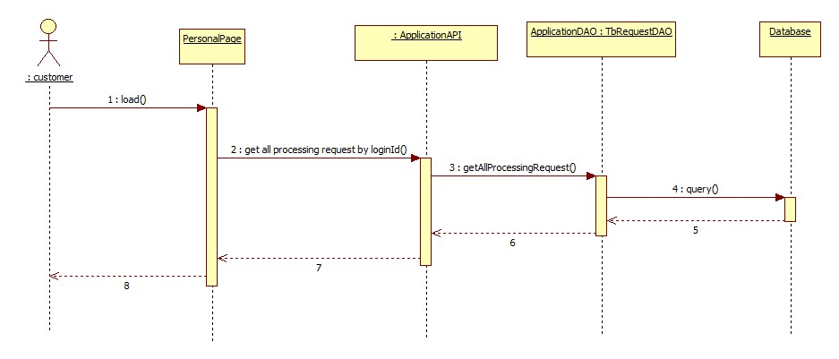

Figure 45 Customer view all processing request

### Customer view all history request

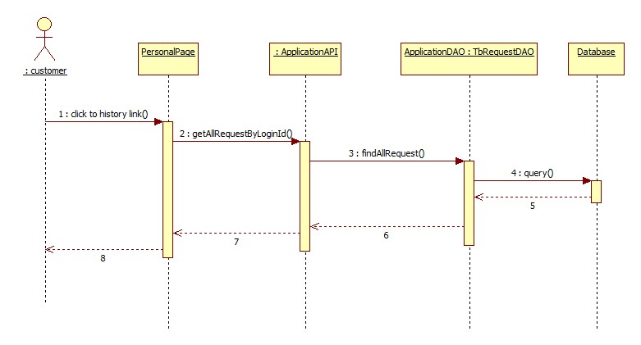

Figure 46 Customer View All History Request

### Customer submit new request

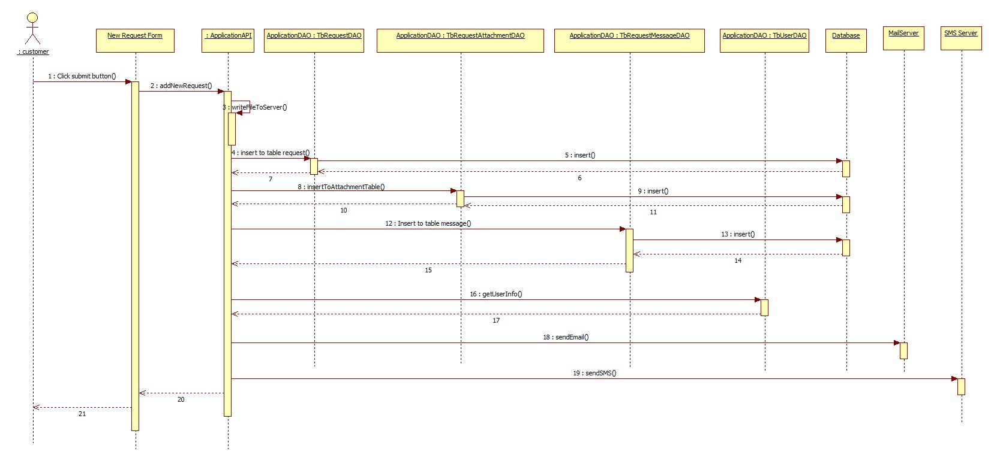

Figure 47 Customer Submit new request

### Manager view all request

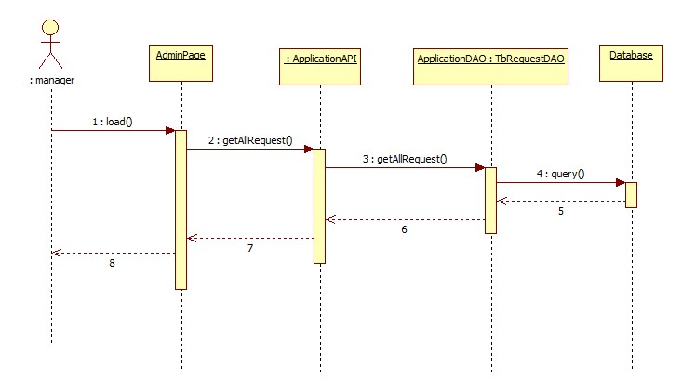

Figure 48 Manager view all request

### Designer view all request assigned to designer

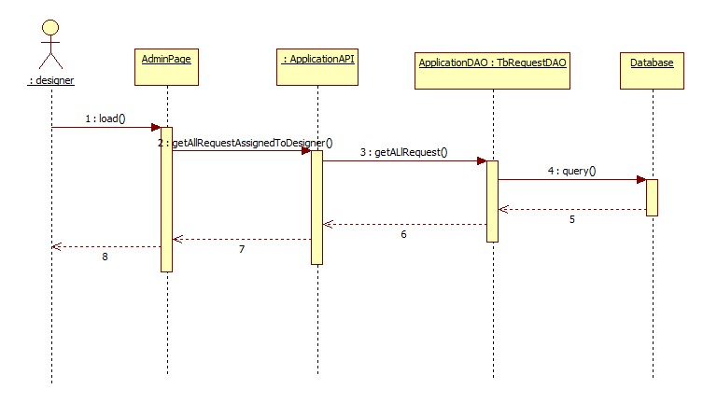

Figure 49 Designer View All Request assign to Designer

### View gallery of template

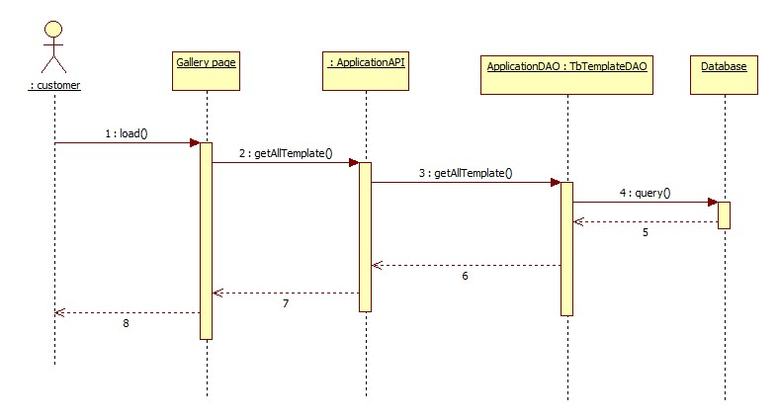

Figure 50 View Gallery of template

### Managers accept request and assign to designer

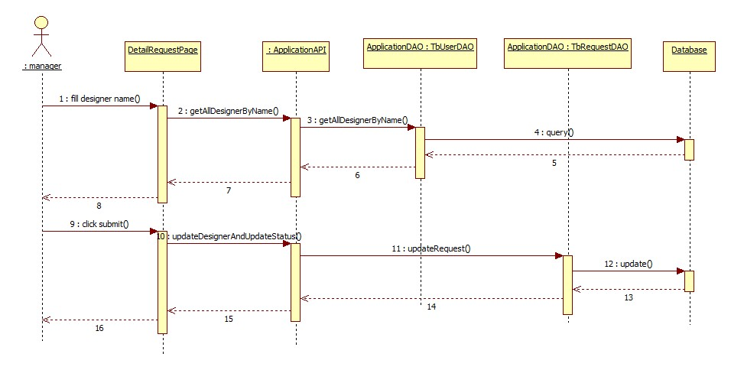

Figure 51 Manager Assign to Designer

### Designer upload template

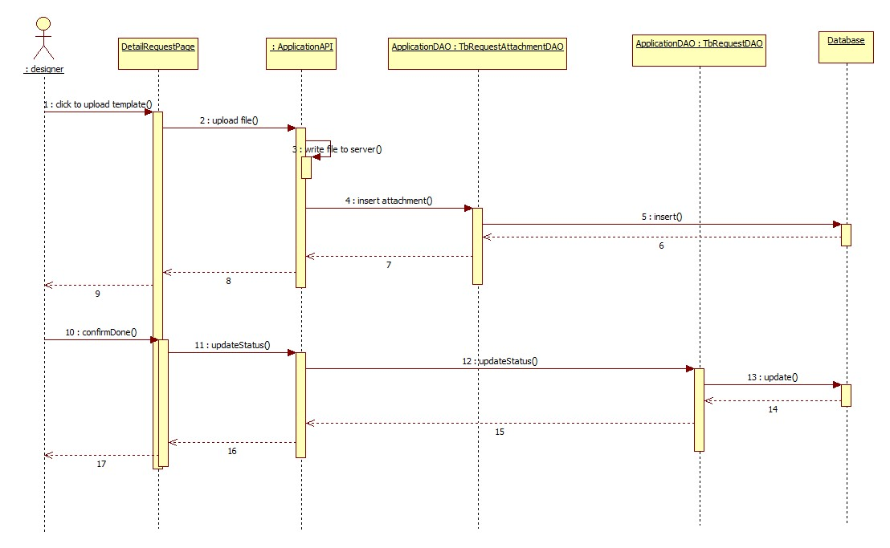

Figure 52 Designer upload new template

### Designer confirm final drawing

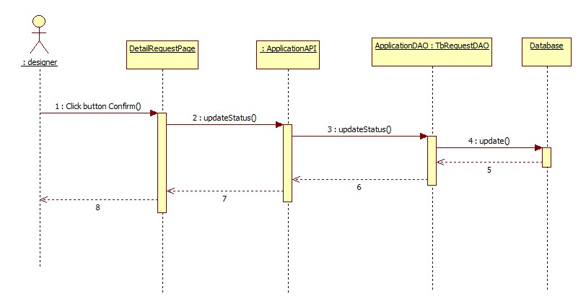

Figure 53 Designer Confirm Final Drawing

### Customer choose suggestion template

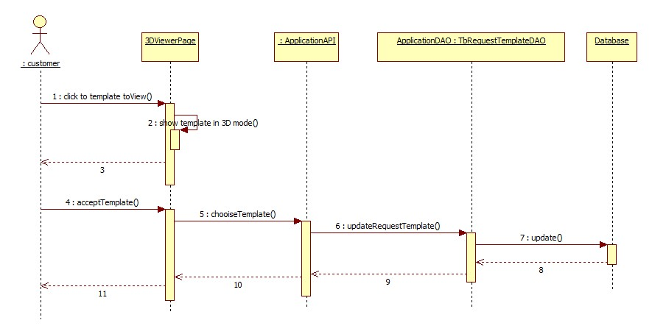

Figure 54 Customer choose suggest template

### Designer suggest template

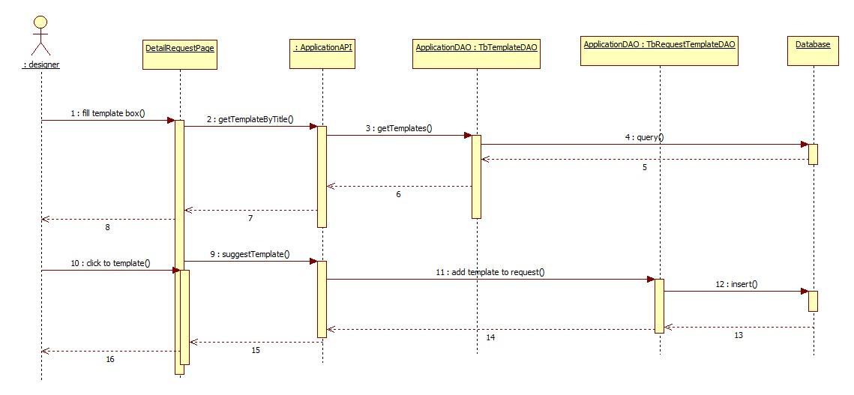

Figure 55 Designer Suggest Template

### Manager confirm payment

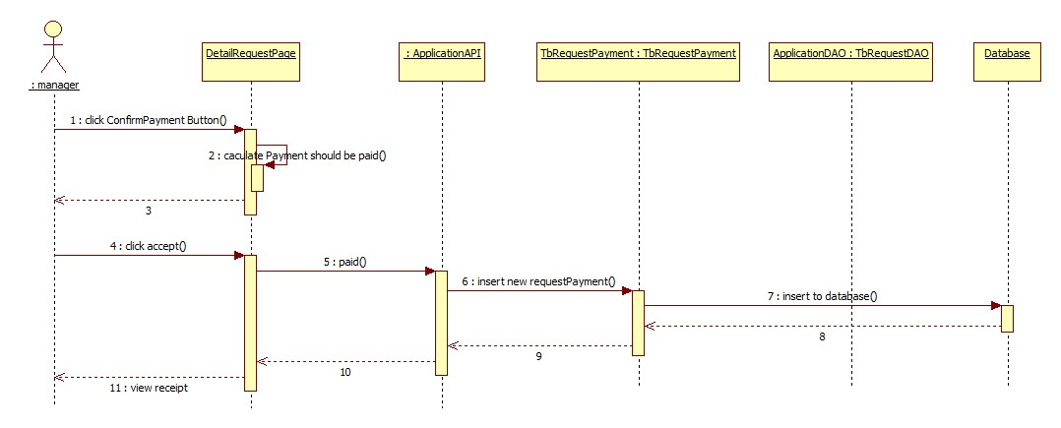

Figure 56 Manager confirm payment

### Login

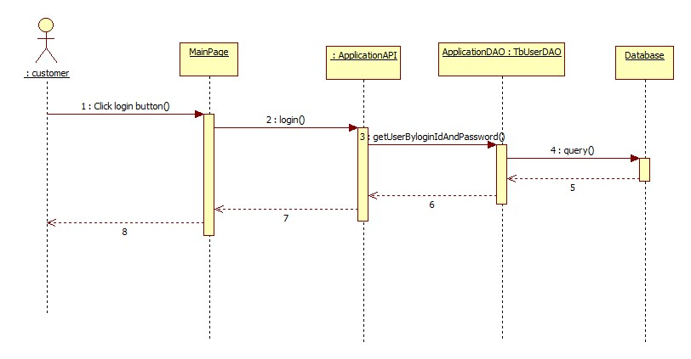

Figure 57 Login

### Register

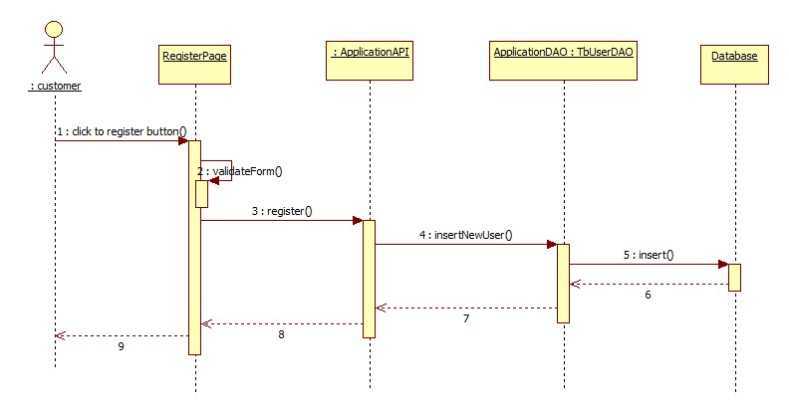

Figure 58 Register

## User Interface design

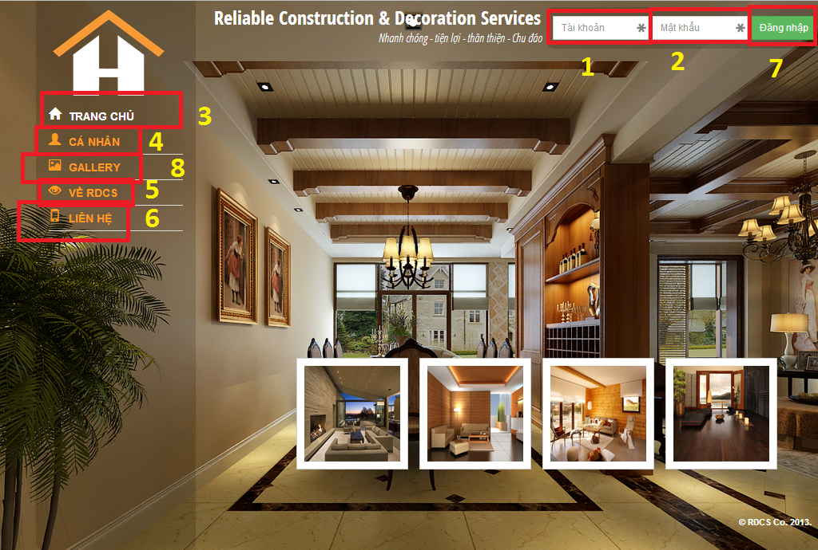

**User Homepage**

**Field:**

|  |  |  |  |  |  |  |  |
| --- | --- | --- | --- | --- | --- | --- | --- |
| No | Field Name | Description | Read  only | Mand  -atory | Control  Type | Data  Type | Length |
| 1 | Tài Khoản | User ID | No | Yes | Textbox | String | 12 characters |
| 2 | Mật Khẩu | Password | No | Yes | Textbox | String | 32 characters |

**Buttons/Hyperlink:**

|  |  |  |  |  |  |
| --- | --- | --- | --- | --- | --- |
| No | Function | Description | Available Criteria | Validation | Outcome |
| 3 | Trang Chủ | Click to return HomePage. | Always | No | Homepage. |
| 4 | Cá Nhân | Click to transfer to Personal Page. | Always | No | Personal Page. |
| 5 | Về RDCS | Click to view RDCS’s infortmation. | Always | No | Information Page. |
| 6 | Liên Hệ | Way to contact with RDCS’s agent. | Always | No | Contact Page. |
| 7 | Đăng Nhập | Click to Login | Always | No | Homepage |
| 8 | Gallery | Click to view system’s template | Always | No | Gallery page. |

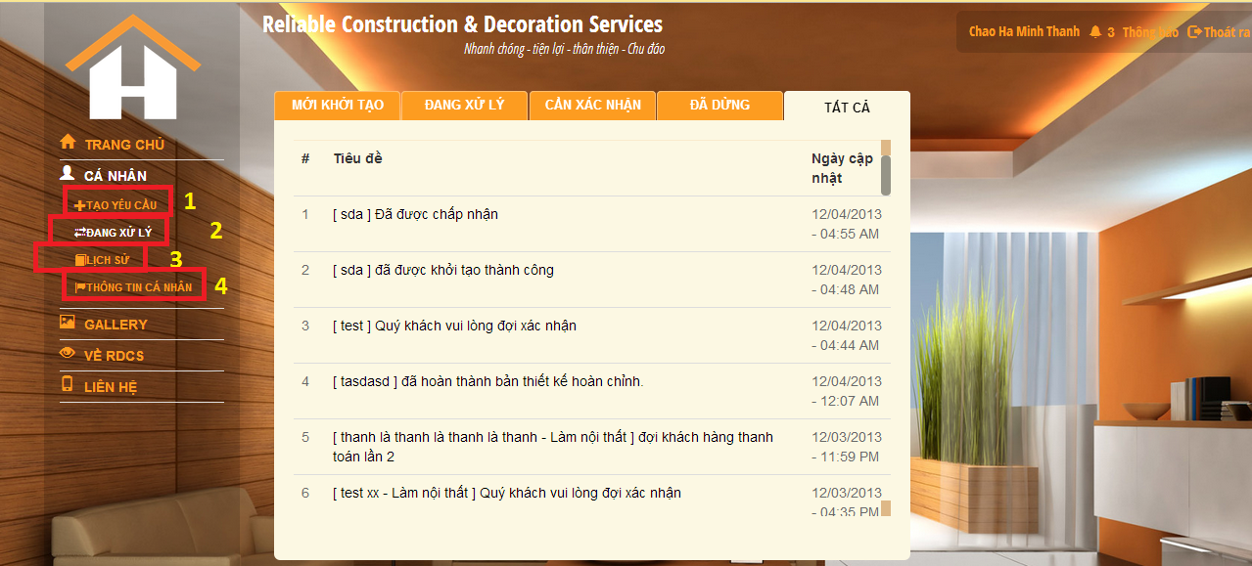

**User Request Detail**

**Buttons/Hyperlink:**

|  |  |  |  |  |  |
| --- | --- | --- | --- | --- | --- |
| No | Function | Description | Available Criteria | Validation | Outcome |
| 1 | Tạo Yêu Cầu | Insert New Request to system | Always | No | Proccessing Page. |
| 2 | Đang Xử Lý | Proccessing Page. | Always | No | Personal Page. |
| 3 | Lịch Sử | View Request History | Always | No | Information Page. |
| 4 | Thông Tin Cá Nhân | View User’s Personal information | Always | No | Personal information Page. |

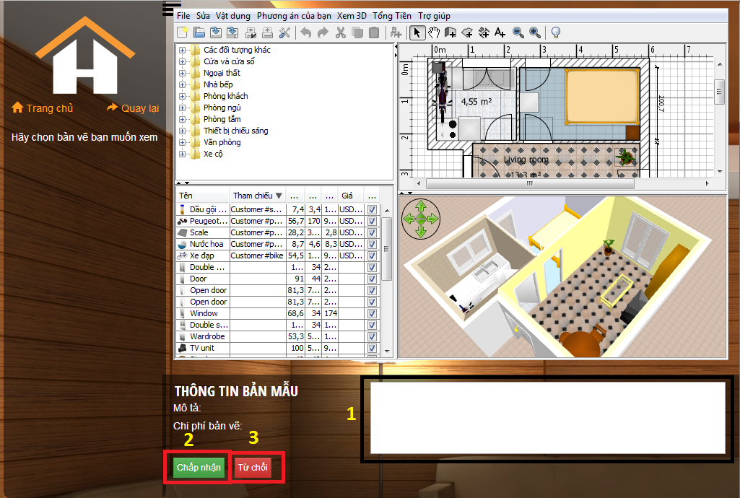

**User Modify 3D**

**Field:**

|  |  |  |  |  |  |  |  |
| --- | --- | --- | --- | --- | --- | --- | --- |
| No | Field Name | Description | Read  only | Mand  -atory | Control  Type | Data  Type | Length |
| 1 | Mô Tả | Customer’s description | No | Yes | Textbox | String | No Limit |

**Buttons/Hyperlink:**

|  |  |  |  |  |  |
| --- | --- | --- | --- | --- | --- |
| No | Function | Description | Available Criteria | Validation | Outcome |
| 2 | Chấp Nhận | Customer approve 3D drawing. | Always | No | Proccessing Page. |
| 3 | Từ Chối | Customer approve 3D drawing. | Always | No | Proccessing Page. |

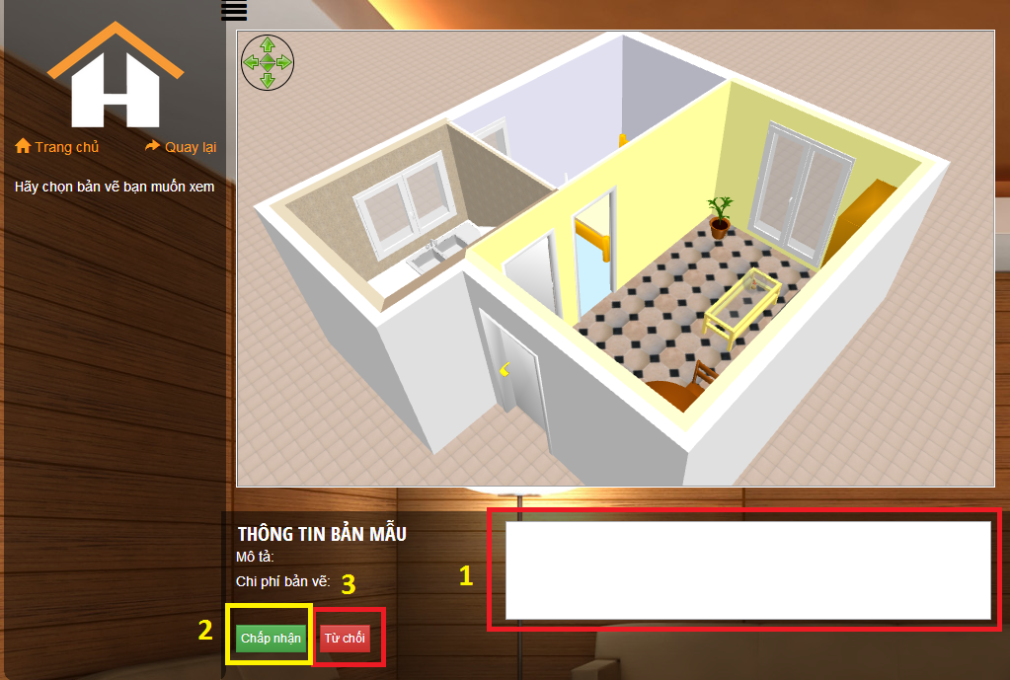

**User View 3D**

**Field:**

|  |  |  |  |  |  |  |  |
| --- | --- | --- | --- | --- | --- | --- | --- |
| No | Field Name | Description | Read  only | Mand  -atory | Control  Type | Data  Type | Length |
| 1 | Mô Tả | Customer’s description | No | Yes | Textbox | String | No Limit |

**Buttons/Hyperlink:**

|  |  |  |  |  |  |
| --- | --- | --- | --- | --- | --- |
| No | Function | Description | Available Criteria | Validation | Outcome |
| 2 | Chấp Nhận | Customer approve 3D drawing. | Always | No | Proccessing Page. |
| 3 | Từ Chối | Customer approve 3D drawing. | Always | No | Proccessing Page. |

## Database design

### Entity relationship diagram

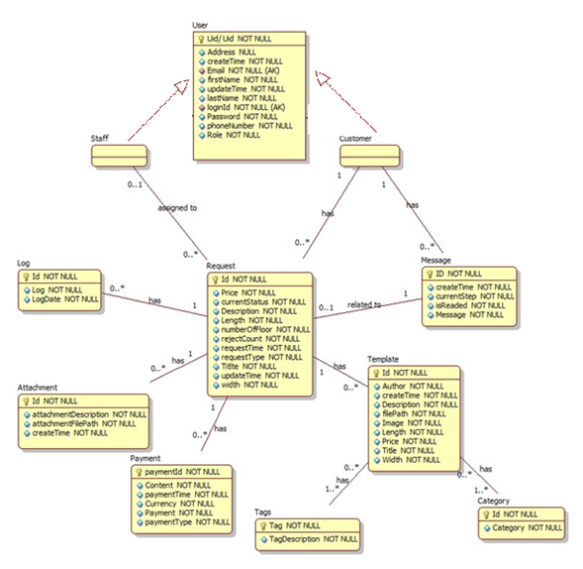

Figure 59 Entity Relationship diagram

### Data dictionary

|  |  |
| --- | --- |
| **Entity Data dictionary: describe content of all entities** | |
| Entity Name | Description |
| Request | Describe all request on RDCS system. |
| Log | Describe all log belong to request in RDCS system. |
| Payment | Describe payment belong to request in RDCS system. |
| User | Describe all user in in RDCS system. |
| Message | Describe all message for user related to request in RDCS system |
| Attachment | Describe all attachment belong to request. |
| Payment | Describe all payment belong to request. |
| Template | Describe all templatesin RDCS system. |
| Tag | Describe all tags for template. |
| Category | Describe all category for template. |

# System Implementation & Test

## Introduction

### 1.1 System Overview

This section provides in detail all necessary information about test plans, test cases, test result, test environments, pass/fail criteria and risks estimations as well as a checklist to cover all possible cases of RDCS.

### 1.2 Test Approach

-Goal: To test the whole system based on the core workflow.

-Method: SystemTesting, Black-box Testing.

## Database Relationship Diagram

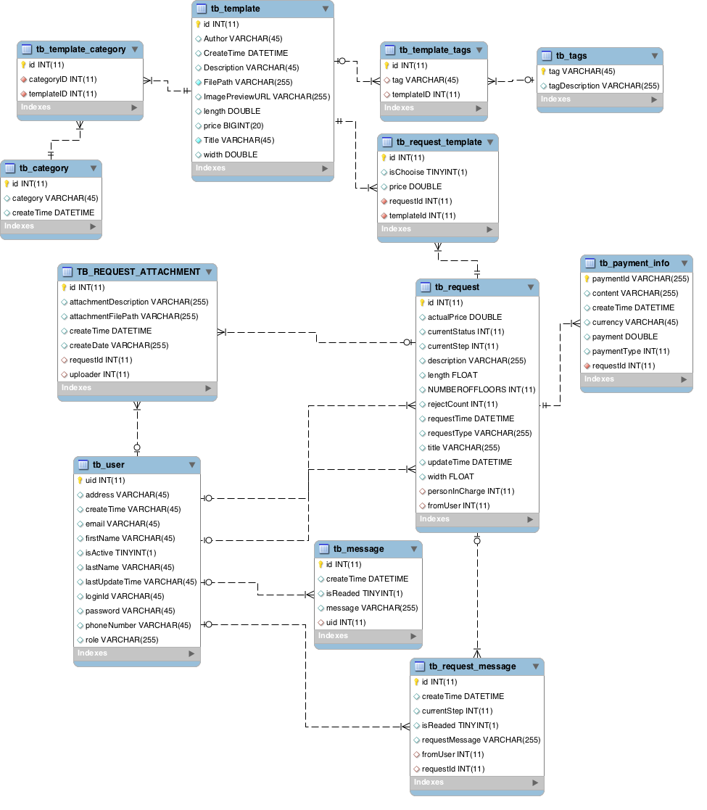

Figure 60 Database Relationship Diagram

## System Testing Test Case

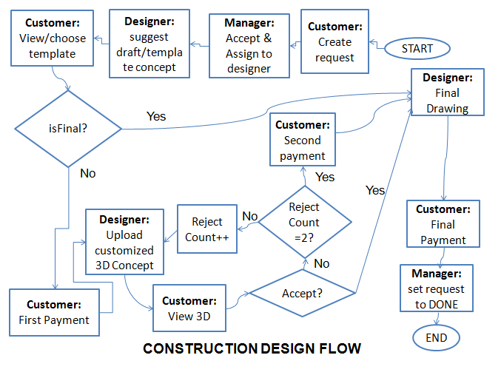

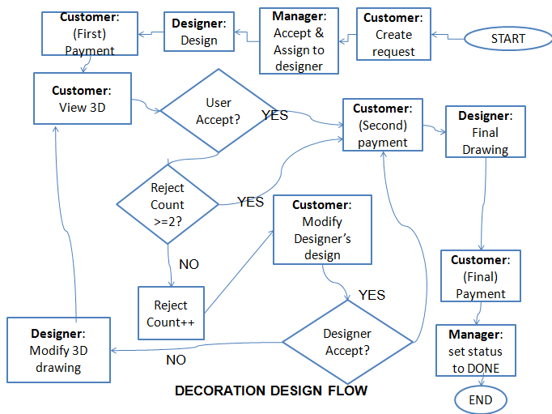

Figure 62: Core Workflow

|  |  |  |  |  |  |  |
| --- | --- | --- | --- | --- | --- | --- |
| **ID** | **Test Case Description** | **Test Case Procedure** | **Expected output** | **Result** | **Test Date** | **Note** |
| ST01 | Customer create new request for construction service | 1. Login as customer account. 2. Click to “Cá nhân” 3. Fill submit form information. 4. Submit | * Redirect to Processing request list pages | Passed | 05/12/2013 |  |
| ST02 | Normal construction service flow 1 | 1. In home page, login as customer account. 2. Click to “cá nhân” 3. Fill submit form information 4. Submit 5. In admin page, Login as manager. 6. In the list of processing request, click to “chi tiết” to view detail of request. 7. Fill designer name to find out designer named “hung” . 8. Click button “chấp nhận” 9. In admin page, login in with account “hung” as designer. 10. In processing request, click in request latest assigned to designer. 11. Click to upload button. 12. Select template to upload 13. Click “chấp nhận” to change state. 14. Back to user account, in processing request list, click to view detail. 15. In request detail page, click to link “Xem bản mẫu” to move to view 3D page. 16. In 3D viewer page, click the template in left side to view 3D. 17. Click “Chấp nhận” to choose the template 18. In popup view, choose this template as final part. 19. In designer, after physical drawing the design, click to “Chấp nhận” to confirm that the final drawing is finish. 20. In manager page, manager click to “Xác nhận thanh toán” to confirm that customer has already charged. | * After step 4, the new request should be created * After step 8, the request status should be changed to “Accept”, and notification should be send to customer via SMS and internal message * After step 13, the status should be change to “ Wait for customer choose template” * After step 20, the request status should be changed to done | Passed | 05/12/2013 |  |
| ST03 | Normal construction service flow 2 | 1. In home page, login as customer account. 2. Click to “cá nhân” 3. Fill submit form information 4. Submit 5. In admin page, Login as manager. 6. In the list of processing request, click to “chi tiết” to view detail of request. 7. Fill designer name to find out designer named “hung” . 8. Click button “chấp nhận” 9. In admin page, login in with account “hung” as designer. 10. In processing request, click in request latest assigned to designer. 11. Click to upload button. 12. Select template to upload 13. Click “chấp nhận” to change state. 14. Back to user account, in processing request list, click to view detail. 15. In request detail page, click to link “Xem bản mẫu” to move to view 3D page. 16. In 3D viewer page, click the template in left side to view 3D. 17. Click “Chấp nhận” to choose the template 18. In popup view, choose this template as not final part. 19. Click to “Thanh toán button” to charge via PayPal. 20. After charge done, in designer page, click to this request to view detail request 21. Click to “upload bản vẽ” button 22. Upload page is shown, click to file to select file 3D with sh3d extension 23. Click to “xác nhân” button to confirm that the file 3D have already uploaded for customer 24. In customer page, Click to request detail, click to “Xem bản vẽ”. 25. In 3D viewer page, user view the template as 3D. 26. User click to “Chấp nhận” button to approve this 3D drawing 27. In designer, after physical drawing the design, click to “Chấp nhận” to confirm that the final drawing is finish. 28. In manager page, manager click to “Xác nhận thanh toán” to confirm that customer has already charged. | * After step 4, the new request should be created * After step 8, the request status should be changed to “Accept”, and notification should be send to customer via SMS and internal message * After step 13, the status should be change to “ Wait for customer choose template” * After step 28, the request status should be changed to done | Passed | 2013-12-03 |  |
|  | Normal construction service flow 3 | 1. In home page, login as customer account. 2. Click to “cá nhân” 3. Fill submit form information 4. Submit 5. In admin page, Login as manager. 6. In the list of processing request, click to “chi tiết” to view detail of request. 7. Fill designer name to find out designer named “hung” . 8. Click button “chấp nhận” 9. In admin page, login in with account “hung” as designer. 10. In processing request, click in request latest assigned to designer. 11. Click to upload button. 12. Select template to upload 13. Click “chấp nhận” to change state. 14. Back to user account, in processing request list, click to view detail. 15. In request detail page, click to link “Xem bản mẫu” to move to view 3D page. 16. In 3D viewer page, click the template in left side to view 3D. 17. Click “Chấp nhận” to choose the template 18. In popup view, choose this template as not final part. 19. Click to “Thanh toán button” to charge via PayPal. 20. After charge done, in designer page, click to this request to view detail request 21. Click to “upload bản vẽ” button 22. Upload page is shown, click to file to select file 3D with sh3d extension 23. Click to “xác nhân” button to confirm that the file 3D have already uploaded for customer 24. In customer page, Click to request detail, click to “Xem bản vẽ”. 25. In 3D viewer page, user view the template as 3D. 26. User click to “Không chấp nhận” button to reject this this 3D drawing 27. In designer page, click to this request to view detailed request 28. Click to “upload bản vẽ” button to re-upload new template for customer 29. In customer page, Click to request detail, click to “Xem bản vẽ”. 30. In 3D viewer page, user view the template as 3D. 31. User click to “Chấp nhận” button to accept this this 3D drawing 32. In designer, after physical drawing the design, click to “Chấp nhận” to confirm that the final drawing is finish. 33. In manager page, manager click to “Xác nhận thanh toán” to confirm that customer has already charged. | * After step 4, the new request should be created * After step 8, the request status should be changed to “Accept”, and notification should be send to customer via SMS and internal message * After step 13, the status should be change to “ Wait for customer choose template” * After step 33, the request status should be changed to done | Passed | 2013-12-03 |  |
|  | Normal construction service flow 4 | 1. In home page, login as customer account. 2. Click to “cá nhân” 3. Fill submit form information 4. Submit 5. In admin page, Login as manager. 6. In the list of processing request, click to “chi tiết” to view detail of request. 7. Fill designer name to find out designer named “hung” . 8. Click button “chấp nhận” 9. In admin page, login in with account “hung” as designer. 10. In processing request, click in request latest assigned to designer. 11. Click to upload button. 12. Select template to upload 13. Click “chấp nhận” to change state. 14. Back to user account, in processing request list, click to view detail. 15. In request detail page, click to link “Xem bản mẫu” to move to view 3D page. 16. In 3D viewer page, click the template in left side to view 3D. 17. Click “Chấp nhận” to choose the template 18. In popup view, choose this template as not final part. 19. Click to “Thanh toán button” to charge via PayPal. 20. After charge done, in designer page, click to this request to view detail request 21. Click to “upload bản vẽ” button 22. Upload page is shown, click to file to select file 3D with sh3d extension 23. Click to “xác nhân” button to confirm that the file 3D have already uploaded for customer 24. In customer page, Click to request detail, click to “Xem bản vẽ”. 25. In 3D viewer page, user view the template as 3D. 26. User click to “Không chấp nhận” button to reject this this 3D drawing 27. In designer page, click to this request to view detailed request 28. Click to “upload bản vẽ” button to re-upload new template for customer 29. In customer page, Click to request detail, click to “Xem bản vẽ”. 30. In 3D viewer page, user view the template as 3D. 31. User click to “Không chấp nhận” button to reject this this 3D drawing 32. In designer page, click to this request to view detailed request 33. Click to “upload bản vẽ” button to re-upload new template for customer 34. In customer page, Click to request detail, click to “Xem bản vẽ”. 35. In 3D viewer page, user view the template as 3D. 36. User click to “Chấp nhận” button to accept this this 3D drawing 37. In designer, after physical drawing the design, click to “Chấp nhận” to confirm that the final drawing is finish. 38. In manager page, manager click to “Xác nhận thanh toán” to confirm that customer has already charged. | * After step 4, the new request should be created * After step 8, the request status should be changed to “Accept”, and notification should be send to customer via SMS and internal message * After step 13, the status should be change to “ Wait for customer choose template”   After step 33, the request status should be changed to done | Passed | 2013-12-03 |  |
|  | Normal flow construction service.  User cancel request | 1. In home page, login as customer account. 2. Click to “cá nhân” 3. Fill submit form information 4. Submit 5. In admin page, Login as manager. 6. In the list of processing request, click to “chi tiết” to view detail of request. 7. Fill designer name to find out designer named “hung” . 8. Click button “chấp nhận” 9. In admin page, login in with account “hung” as designer. 10. In processing request, click in request latest assigned to designer. 11. Click to upload button. 12. Select template to upload 13. Click “chấp nhận” to change state. 14. Back to user account, in processing request list, click to view detail. 15. In request detail page, click to link “Xem bản mẫu” to move to view 3D page. 16. In 3D viewer page, click the template in left side to view 3D. 17. Click “Chấp nhận” to choose the template 18. In popup view, choose this template as not final part. 19. Click to “Thanh toán button” to charge via PayPal. 20. After charge done, in designer page, click to this request to view detail request 21. Click to “upload bản vẽ” button 22. Upload page is shown, click to file to select file 3D with sh3d extension 23. Click to “xác nhân” button to confirm that the file 3D have already uploaded for customer 24. In customer page, Click to request detail, click to “Xem bản vẽ”. 25. In 3D viewer page, user view the template as 3D. 26. User click to “Không chấp nhận” button to reject this this 3D drawing 27. In designer page, click to this request to view detailed request 28. Click to “upload bản vẽ” button to re-upload new template for customer 29. In customer page, Click to request detail, click to “Xem bản vẽ”. 30. In 3D viewer page, user view the template as 3D. 31. User click to “Không chấp nhận” button to reject this this 3D drawing 32. In designer page, click to this request to view detailed request 33. Click to “upload bản vẽ” button to re-upload new template for customer 34. In customer page, Click to request detail, Click to “Hủy bỏ” button. | * After step 4, the new request should be created * After step 8, the request status should be changed to “Accept”, and notification should be send to customer via SMS and internal message * After step 13, the status should be change to “ Wait for customer choose template”   After step 33, the request status should be changed to CANCEL | Passed | 2013-12-03 |  |
|  | Normal flow for decoration service | 1. In home page, login as customer account. 2. Click to “cá nhân” 3. Fill submit form information 4. Submit 5. In admin page, Login as manager. 6. In the list of processing request, click to “chi tiết” to view detail of request. 7. Fill designer name to find out designer named “hung” . 8. Click button “chấp nhận” 9. In admin page, login in with account “hung” as designer. 10. In processing request, click in request latest assigned to designer. 11. Click to upload new template button. 12. Choose file 3D and upload to customer 13. Click to “chấp nhận” to confirm that file 3D have already uploaded 14. In customer page, user click to button “Thanh toán” to pay for first charged 15. After charged, user click to view 3D template to view file 16. In 3D viewer, user click to “Tổng tiền” button to verify total estimation money should have to completed this design. 17. Customer click to “chấp nhận” to accept this template 18. Payment pop up is shown, customer click to “Thanh toán” to charged for the second charge. 19. After customer charge, designer confirm that the final drawing have been done. 20. Manager click to “Xác nhận thanh toán” button to confirm that this manager have already received cash from customer. | The request status should be changed to DONE | Passed | 2013-12-03 |  |
|  | Normal flow for decoration service 2 | 1. In home page, login as customer account. 2. Click to “cá nhân” 3. Fill submit form information 4. Submit 5. In admin page, Login as manager. 6. In the list of processing request, click to “chi tiết” to view detail of request. 7. Fill designer name to find out designer named “hung” . 8. Click button “chấp nhận” 9. In admin page, login in with account “hung” as designer. 10. In processing request, click in request latest assigned to designer. 11. Click to upload new template button. 12. Choose file 3D and upload to customer 13. Click to “chấp nhận” to confirm that file 3D have already uploaded 14. In customer page, user click to button “Thanh toán” to pay for first charged 15. After charged, user click to view 3D template to view file 16. In 3D viewer, user click to “Tổng tiền” button to verify total estimation money should have to completed this design. 17. Customer click to add new furniture in 3D view 18. Customer move the table to the left of the house 19. Customer delete the chair 20. Customer click to “chỉnh sửa” to submit new modify for designer 21. In the designer view, designer click to detail of this request. 22. Designer click to the link to view the modify of customer 23. Designer click to “Chấp nhận” button to accept the modify 24. In the customer view, customer click to “Thanh toán” button for the second charged 25. After customer charge, designer confirm that the final drawing have been done. 26. Manager click to “Xác nhận thanh toán” button to confirm that this manager have already received cash from customer. | The status of request should be changed to done | Passed | 2013-12-03 |  |
|  | Normal decoration service 3 | 1. In home page, login as customer account. 2. Click to “cá nhân” 3. Fill submit form information 4. Submit 5. In admin page, Login as manager. 6. In the list of processing request, click to “chi tiết” to view detail of request. 7. Fill designer name to find out designer named “hung” . 8. Click button “chấp nhận” 9. In admin page, login in with account “hung” as designer. 10. In processing request, click in request latest assigned to designer. 11. Click to upload new template button. 12. Choose file 3D and upload to customer 13. Click to “chấp nhận” to confirm that file 3D have already uploaded 14. In customer page, user click to button “Thanh toán” to pay for first charged 15. After charged, user click to view 3D template to view file 16. In 3D viewer, user click to “Tổng tiền” button to verify total estimation money should have to completed this design. 17. Customer click to add new furniture in 3D view 18. Customer move the table to the left of the house 19. Customer delete the chair 20. Customer click to “chỉnh sửa” to submit new modify for designer 21. In the designer view, designer click to detail of this request. 22. Designer click to the link to view the modify of customer 23. Designer modify the customer modification. 24. Designer click to button “Không chấp nhận” to reject the customer modification and propose designer’s modify 25. user click to view 3D template to view file 26. In 3D viewer, user click to “Tổng tiền” button to verify total estimation money should have to completed this design. 27. Customer click to add new furniture in 3D view 28. Customer move the table to the left of the house 29. Customer delete the chair 30. Customer click to “chỉnh sửa” to submit new modify for designer 31. In the designer view, designer click to detail of this request. 32. Designer click to the link to view the modify of customer 33. Designer click to “chấp nhận” accept the new modification of user. 34. In the customer view, customer click to “Thanh toán” button for the second charged 35. After customer charge, designer confirm that the final drawing have been done. 36. Manager click to “Xác nhận thanh toán” button to confirm that this manager have already received cash from customer. | * The request status should be changed to done | Passed | 2013-12-03 |  |
|  | Normal decoration 4 | 1. In home page, login as customer account. 2. Click to “cá nhân” 3. Fill submit form information 4. Submit 5. In admin page, Login as manager. 6. In the list of processing request, click to “chi tiết” to view detail of request. 7. Fill designer name to find out designer named “hung” . 8. Click button “chấp nhận” 9. In admin page, login in with account “hung” as designer. 10. In processing request, click in request latest assigned to designer. 11. Click to upload new template button. 12. Choose file 3D and upload to customer 13. Click to “chấp nhận” to confirm that file 3D have already uploaded 14. In customer page, user click to button “Thanh toán” to pay for first charged 15. After charged, user click to view 3D template to view file 16. In 3D viewer, user click to “Tổng tiền” button to verify total estimation money should have to completed this design. 17. Customer click to add new furniture in 3D view 18. Customer move the table to the left of the house 19. Customer delete the chair 20. Customer click to “chỉnh sửa” to submit new modify for designer 21. In the designer view, designer click to detail of this request. 22. Designer click to the link to view the modify of customer 23. Designer modify the customer modification. 24. Designer click to button “Không chấp nhận” to reject the customer modification and propose designer’s modify 25. user click to view 3D template to view file 26. In 3D viewer, user click to “Tổng tiền” button to verify total estimation money should have to completed this design. 27. Customer click to add new furniture in 3D view 28. Customer move the table to the left of the house 29. Customer delete the chair 30. Customer click to “chỉnh sửa” to submit new modify for designer 31. In the designer view, designer click to detail of this request. 32. Designer click to the link to view the modify of customer 33. Designer modify the customer modification. 34. Designer click to button “Không chấp nhận” to reject the customer modification and propose designer’s modify 35. user click to view 3D template to view file 36. In 3D viewer, user click to “Tổng tiền” button to verify total estimation money should have to completed this design. 37. Customer click to “chấp nhận” button to accept this modification of user 38. In the customer view, customer click to “Thanh toán” button for the second charged 39. After customer charge, designer confirm that the final drawing have been done. 40. Manager click to “Xác nhận thanh toán” button to confirm that this manager have already received cash from customer. | The request status should be changed to DONE | Passed | 2013-12-03 |  |
|  | Normal decoration service. User cancel | 1. In home page, login as customer account. 2. Click to “cá nhân” 3. Fill submit form information 4. Submit 5. In admin page, Login as manager. 6. In the list of processing request, click to “chi tiết” to view detail of request. 7. Fill designer name to find out designer named “hung” . 8. Click button “chấp nhận” 9. In admin page, login in with account “hung” as designer. 10. In processing request, click in request latest assigned to designer. 11. Click to upload new template button. 12. Choose file 3D and upload to customer 13. Click to “chấp nhận” to confirm that file 3D have already uploaded 14. In customer page, user click to button “Thanh toán” to pay for first charged 15. After charged, user click to view 3D template to view file 16. In 3D viewer, user click to “Tổng tiền” button to verify total estimation money should have to completed this design. 17. Customer click to add new furniture in 3D view 18. Customer move the table to the left of the house 19. Customer delete the chair 20. Customer click to “chỉnh sửa” to submit new modify for designer 21. In the designer view, designer click to detail of this request. 22. Designer click to the link to view the modify of customer 23. Designer modify the customer modification. 24. Designer click to button “Không chấp nhận” to reject the customer modification and propose designer’s modify 25. user click to view 3D template to view file 26. In 3D viewer, user click to “Tổng tiền” button to verify total estimation money should have to completed this design. 27. Customer click to add new furniture in 3D view 28. Customer move the table to the left of the house 29. Customer delete the chair 30. Customer click to “chỉnh sửa” to submit new modify for designer 31. In the designer view, designer click to detail of this request. 32. Designer click to the link to view the modify of customer 33. Designer modify the customer modification. 34. Designer click to button “Không chấp nhận” to reject the customer modification and propose designer’s modify 35. user click to view 3D template to view file 36. In 3D viewer, user click to “Tổng tiền” button to verify total estimation money should have to completed this design. 37. Customer click to “chấp nhận” button to accept this modification of user 38. In the customer view, customer click to “Hủy bỏ” button to cancel the request. | The request status should be changed to CANCEL | Passed | 2013-12-03 |  |
|  |  |  |  |  |  |  |

# Software User’s Manual

## Installation Guide

## Setting up environment at server site

The following software must be installed into the server machine:

## Hardware requirements

Personal computers for developing with the minimum configuration:

* CPU Core 2 Duo 2.0GHz.
* 4GB of RAM.
* 300GB of hard disk.
* Wifi Internet (> 2Mbps).

## Software requirements

* Web Server: Apache Tomcat 7, Apache Web server 2.4
* DBMS: MySQL 5.x

## Deployment at server side

## Prepare deployment package

* Extract the deployment package to a folder on the server.
* For example: D:\Capstone Project

## Deploy webapplication.

* Copy rdcs-api.war in deployment folder to {tomcat7-folder}/webapps folder
* Extract and copy front-end.zip to {tomcat7-folder}/ROOTS folder
* Extract and copy 3D-part.zip to {Apache 2.4-folder}/www/htdocs
* Start tomcat server
* Start apache web server.

## User guide

### Customer

* + 1. **Register**

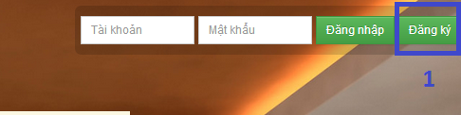

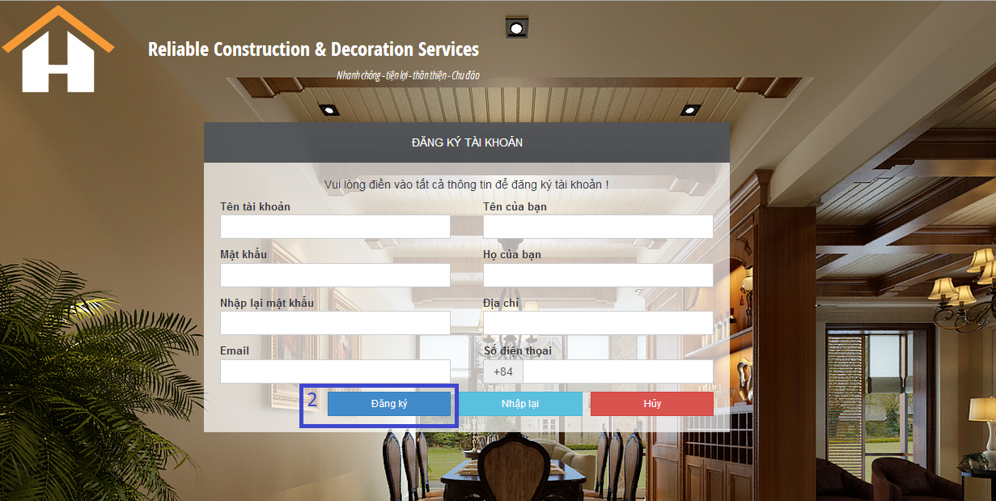

|  |  |
| --- | --- |
| **Step** | **Description** |
| 1 | Click button “Đăng ký” in the header of site |
| 2 | Fill all data and click “Đăng ký” |

* + 1. **Login<đánh dấu màu vàng>**

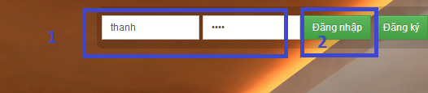

|  |  |
| --- | --- |
| **Step** | **Description** |
| 1 | Fill username and password in the username and password box in the header of site |
| 2 | Click “Đăng nhập” |

* + 1. **Submit new request**

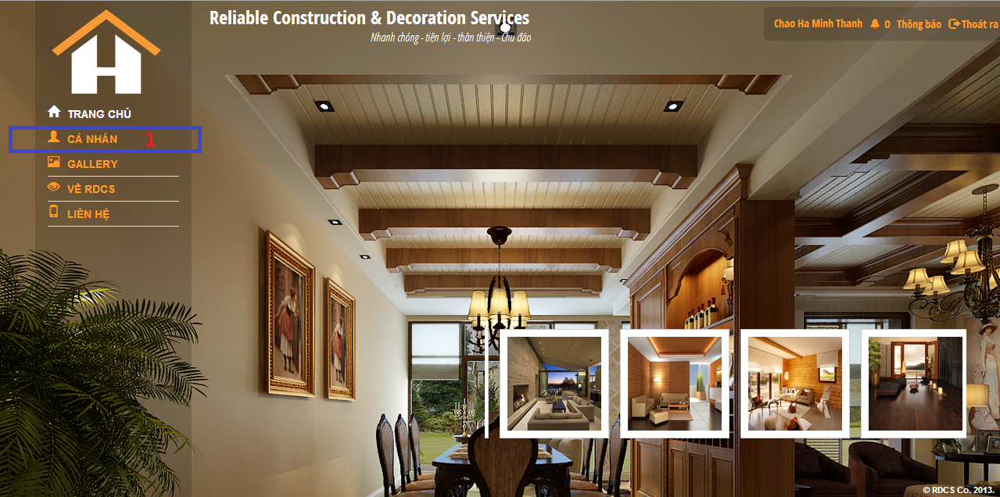

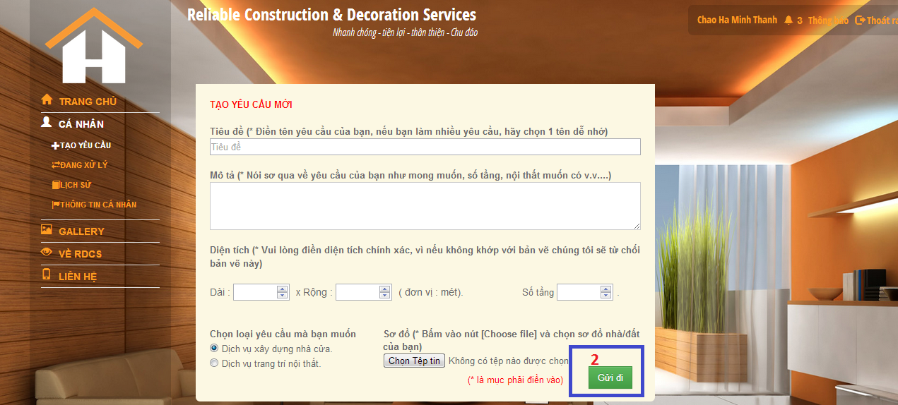

|  |  |
| --- | --- |
| **Step** | **Description** |
| 1 | In the menu in left side, click to “Cá nhân” |
| 2 | Fill and Click to button “Gửi đi” |

* + 1. **View processing request**

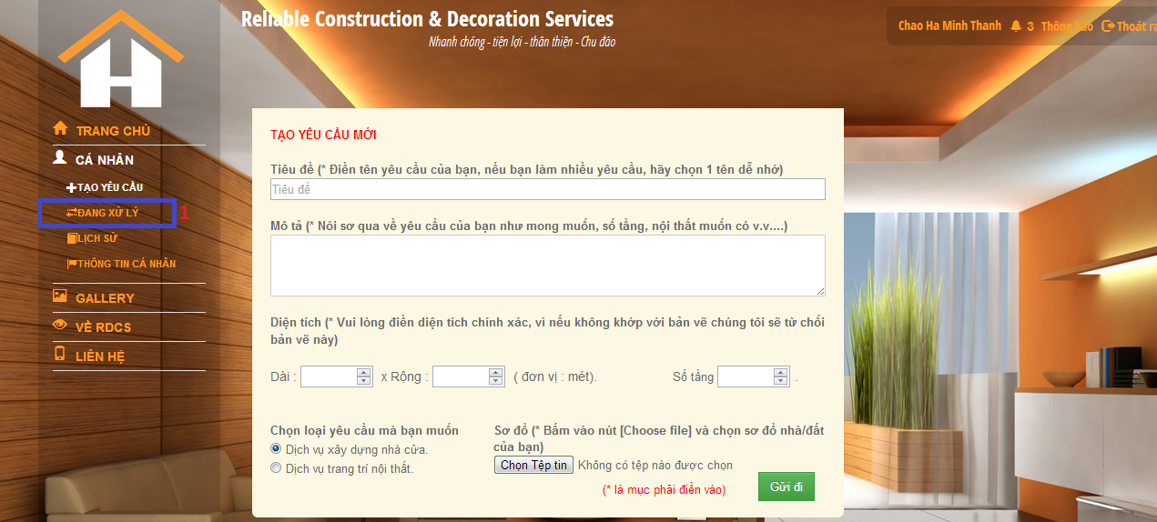

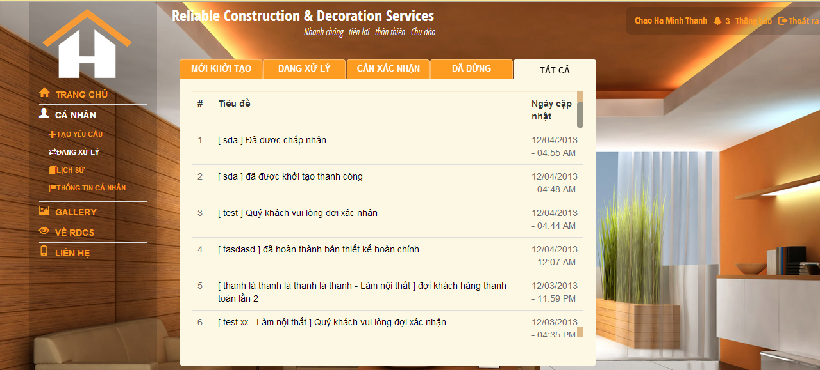

|  |  |
| --- | --- |
| **Step** | **Description** |
| 1 | In the “Cá nhân” pages, click to “Đang xử lý” link |
| 2 | View your processing request |

* + 1. **View request history**

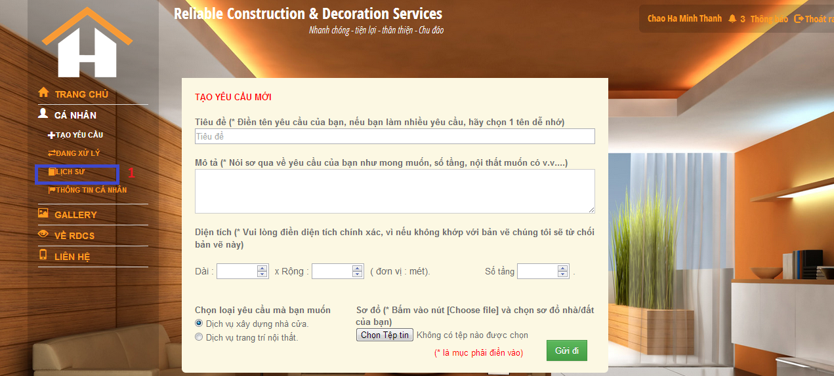

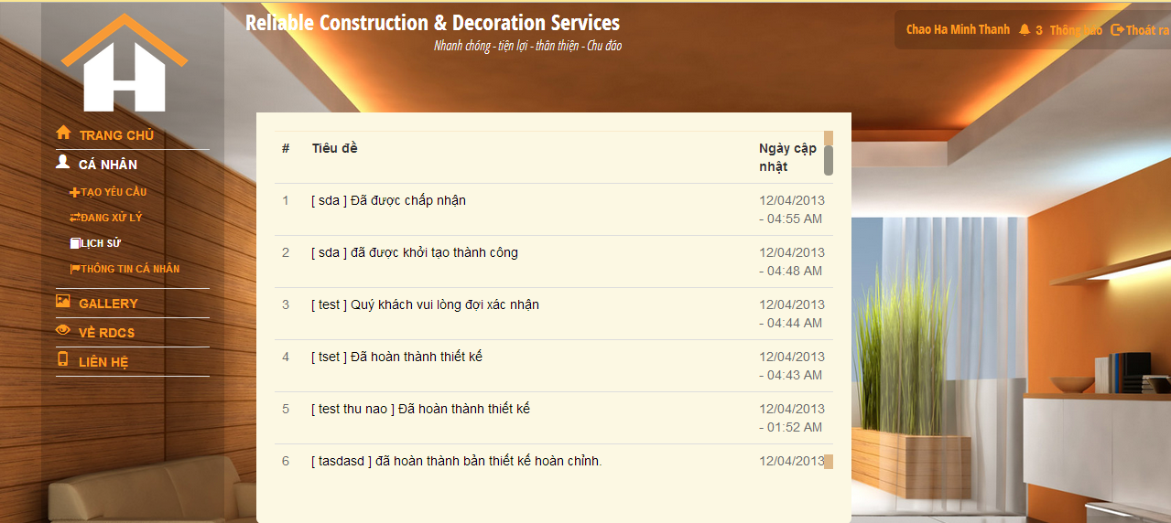

|  |  |
| --- | --- |
| **Step** | **Description** |
| 1 | In the menu in left side, click to “Lịch sử” menu. |
| 2 | View your history of request |

* + 1. **View request detail**

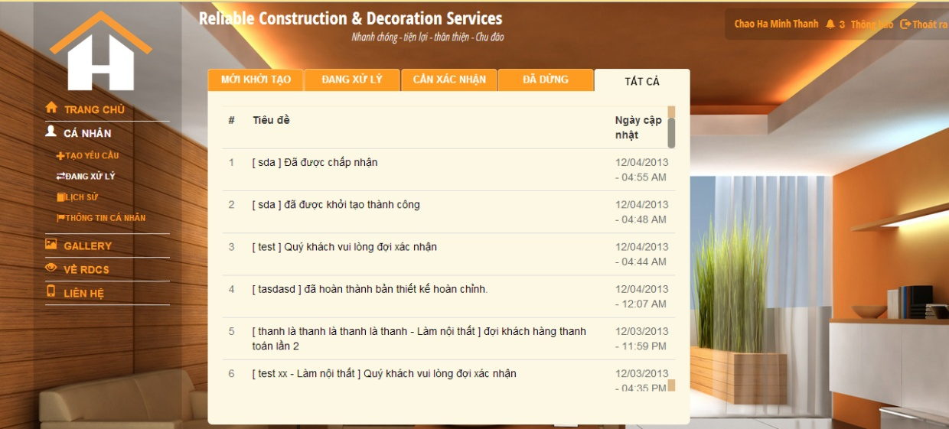

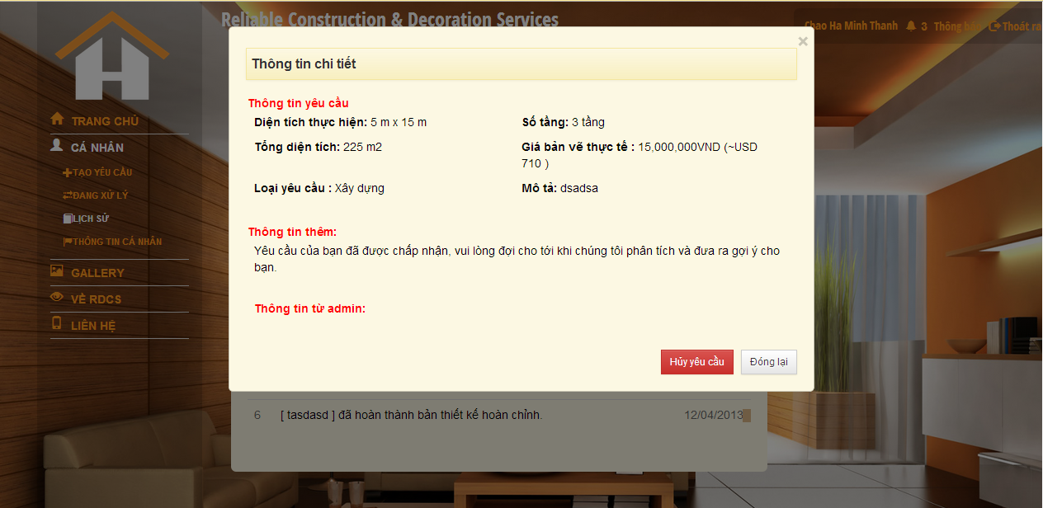

|  |  |
| --- | --- |
| **Step** | **Description** |
| 1 | In the processing request list, click to request in list |
| 2 | View your request detail |

* + 1. **Charge payment**

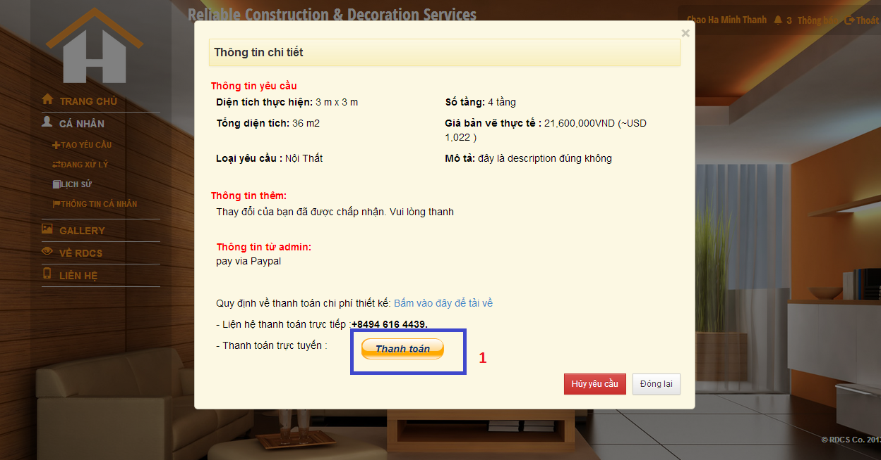

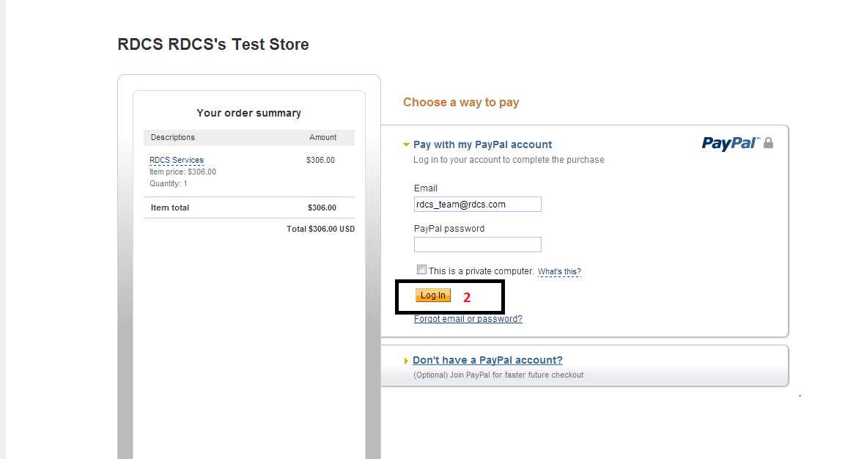

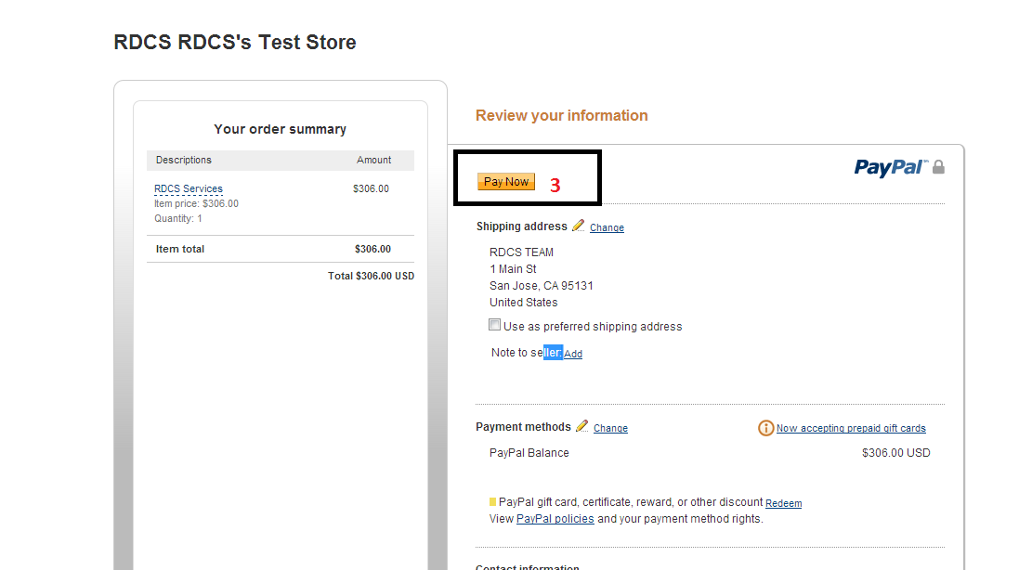

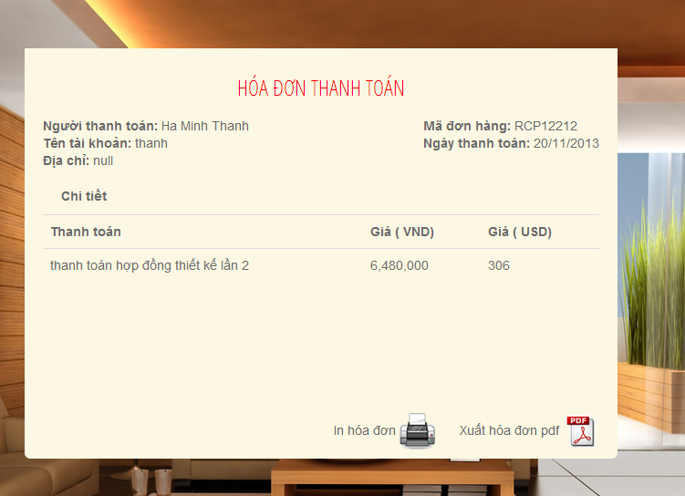

|  |  |
| --- | --- |
| **Step** | **Description** |
| 1 | Click button “Thanh toán” in detail of request page |
| 2 | Login with your paypal account |
| 3 | Charge with PayPal account |
| 4 | View your receipt |

* + 1. **Export payment detail**

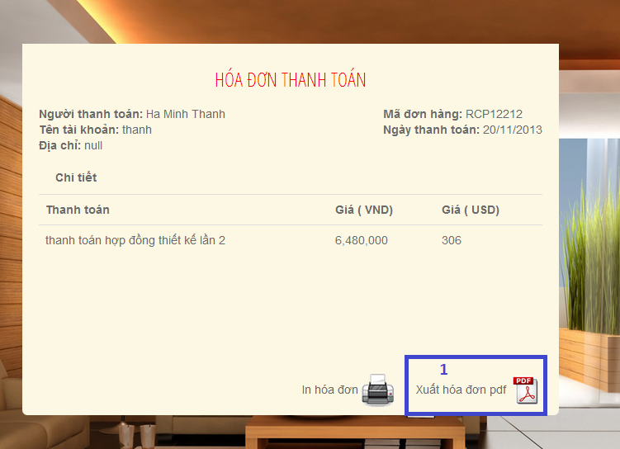

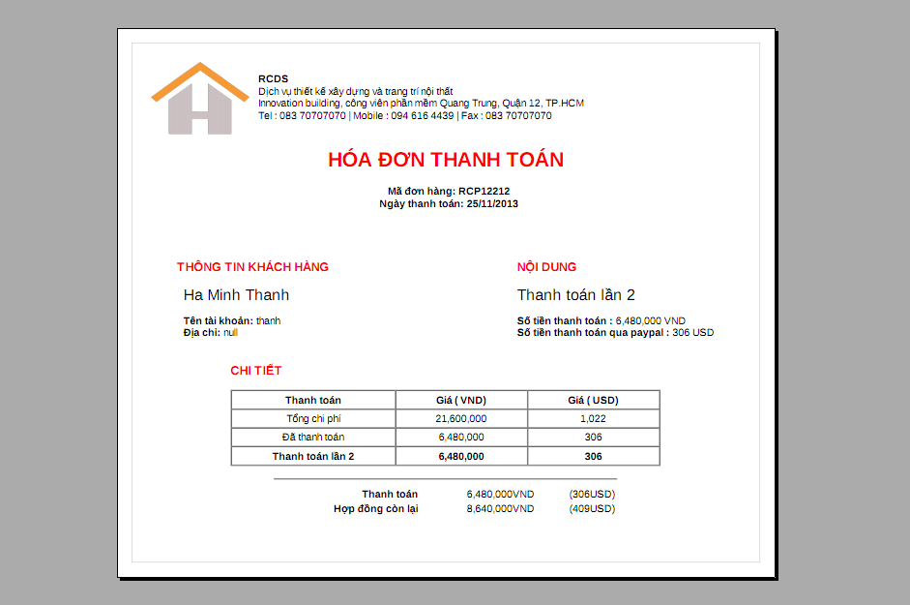

|  |  |
| --- | --- |
| **Step** | **Description** |
| 1 | Click “Xuất hóa đơn PDF” in receipt detail |
| 2 | Download and view your receipt as PDF |

* + 1. **Print payment detail**

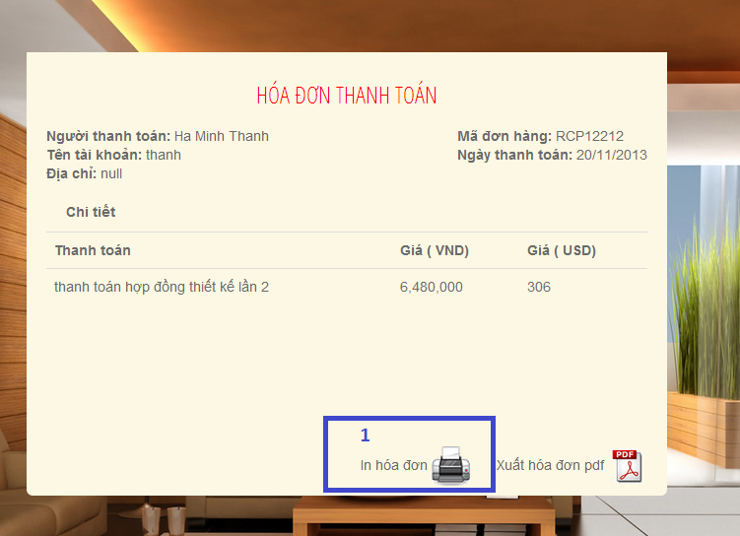

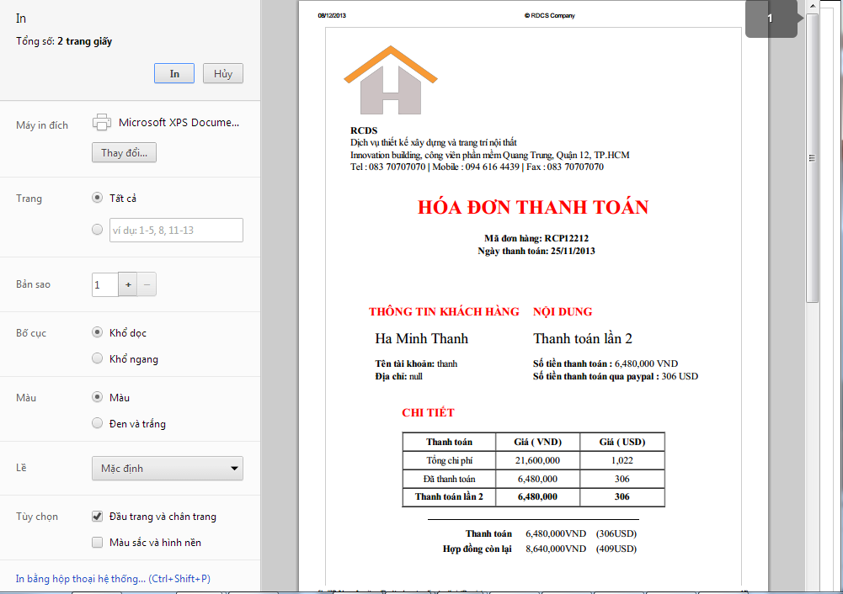

|  |  |
| --- | --- |
| **Step** | **Description** |
| 1 | Click to “In hóa đơn” button |
| 2 | View your preview receipt preview |

* + 1. **View 3D file**

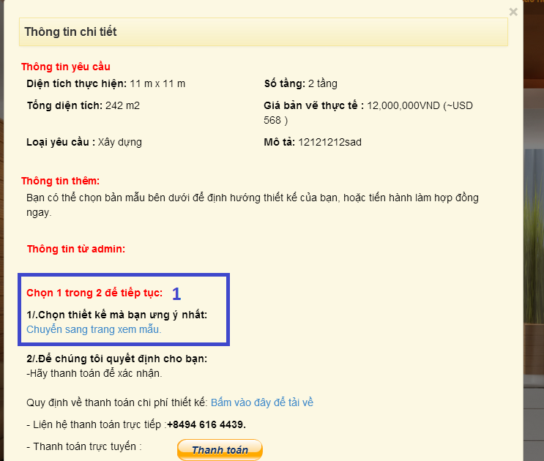

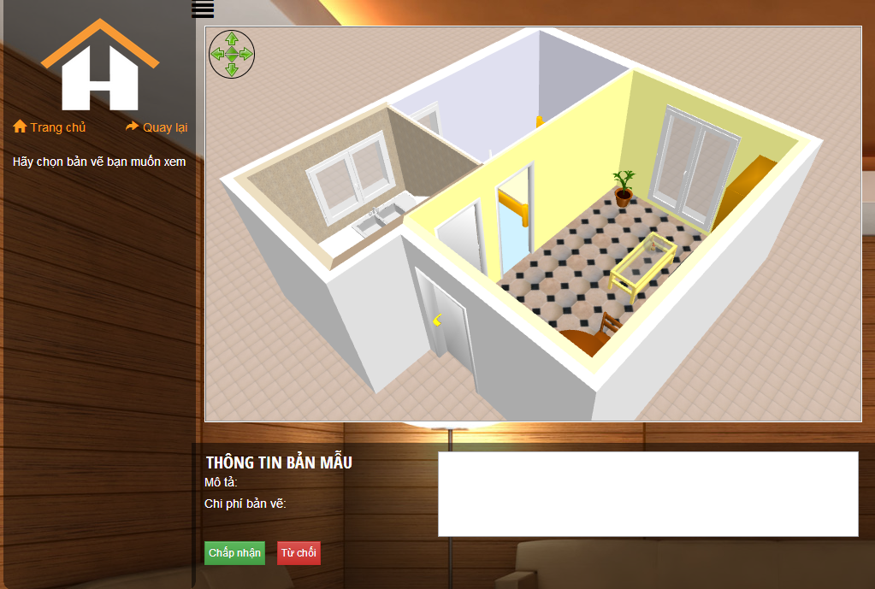

|  |  |
| --- | --- |
| **Step** | **Description** |
| 1 | Click view 3D link in request detail |
| 2 | View your 3D template |

* + 1. **Cancel request**

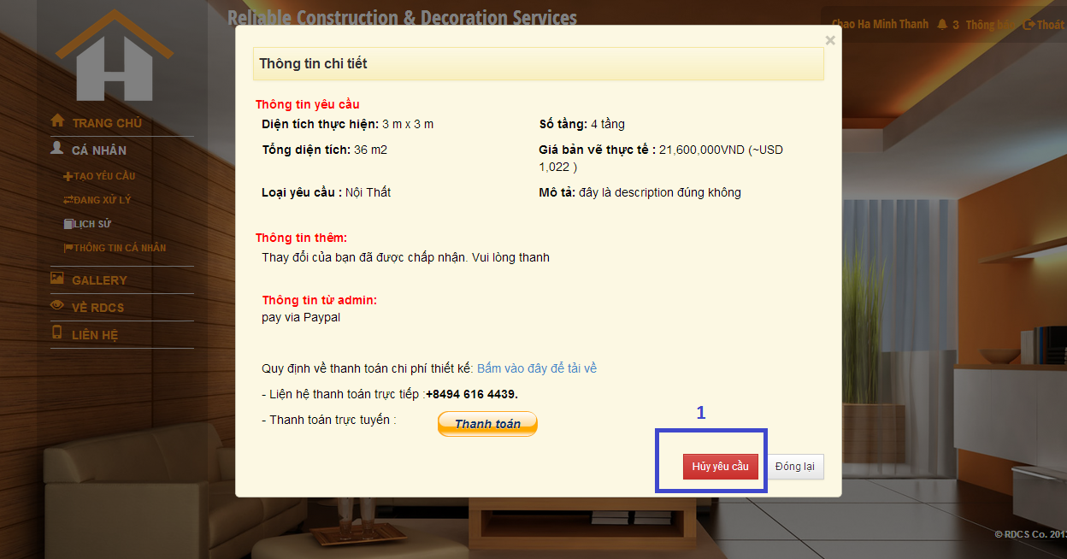

|  |  |
| --- | --- |
| **Step** | **Description** |
| 1 | In the request detail, click “Hủy yêu cầu” button in the left of box. |
|  |  |

* + 1. **Reject 3D drawing**

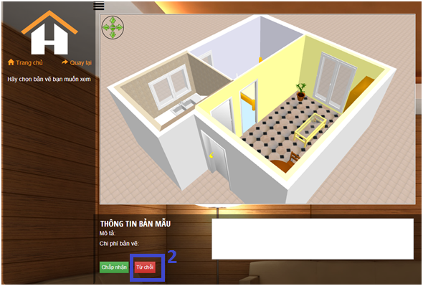

|  |  |
| --- | --- |
| **Step** | **Description** |
| 1 | View your 3D drawing |
| 2 | Click to “Từ chối” button |

* + 1. **Accept 3D drawing**

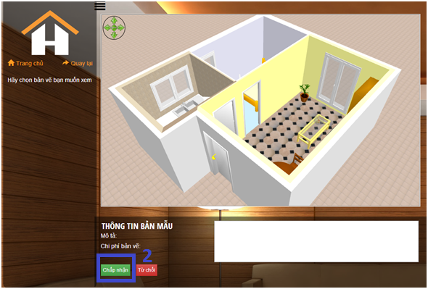

|  |  |
| --- | --- |
| **Step** | **Description** |
| 1 | View your 3D drawing |
| 2 | Click to “Chấp nhận” button |

* + 1. **Modify Designer 3D drawing**

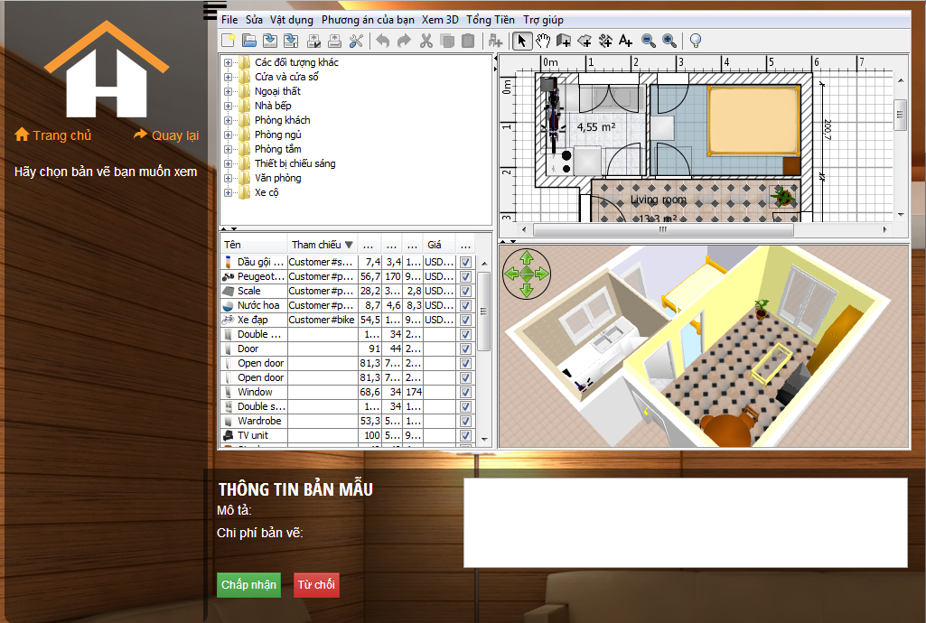

|  |  |
| --- | --- |
| **Step** | **Description** |
| **1** | **View and modify designer drawing** |
| **2** | **Click button “Từ chối”** |

### Manager

* + 1. **Login**

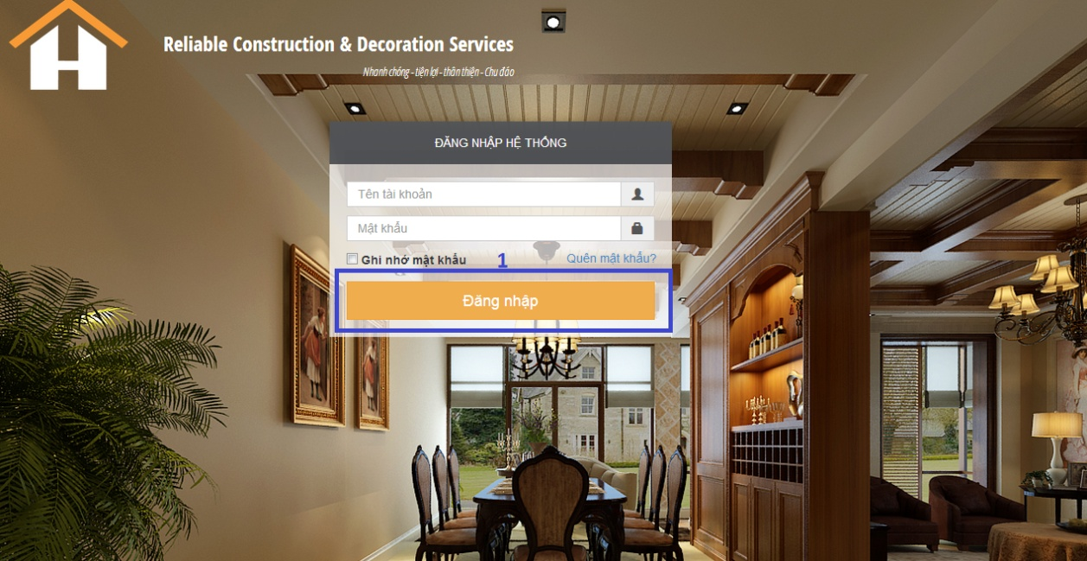

|  |  |
| --- | --- |
| **Step** | **Description** |
| 1 | Fill username and password |
| 2 | Click “Đăng nhập” to login |

* + 1. **View request list**

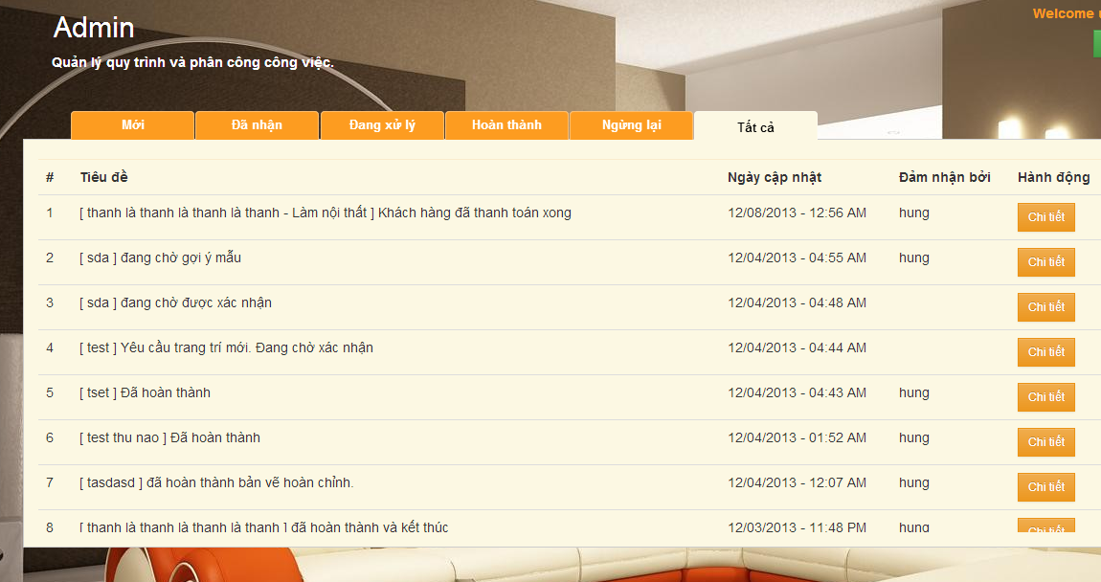

|  |  |
| --- | --- |
| **Step** | **Description** |
| 1 | Login to system |
| 2 | View request list |

* + 1. **View request detail**

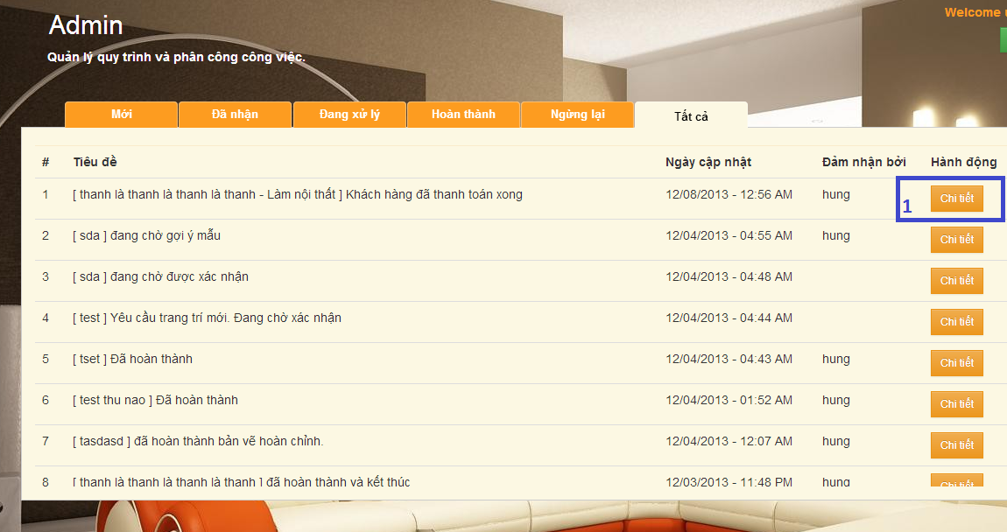

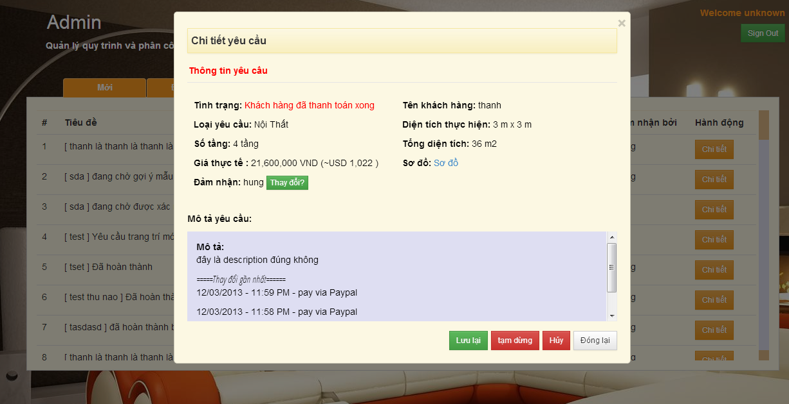

|  |  |
| --- | --- |
| **Step** | **Description** |
| 1 | Click button “Chi tiết” in request list |
| 2 | View the detail of request |

* + 1. **Accept and assign to user**



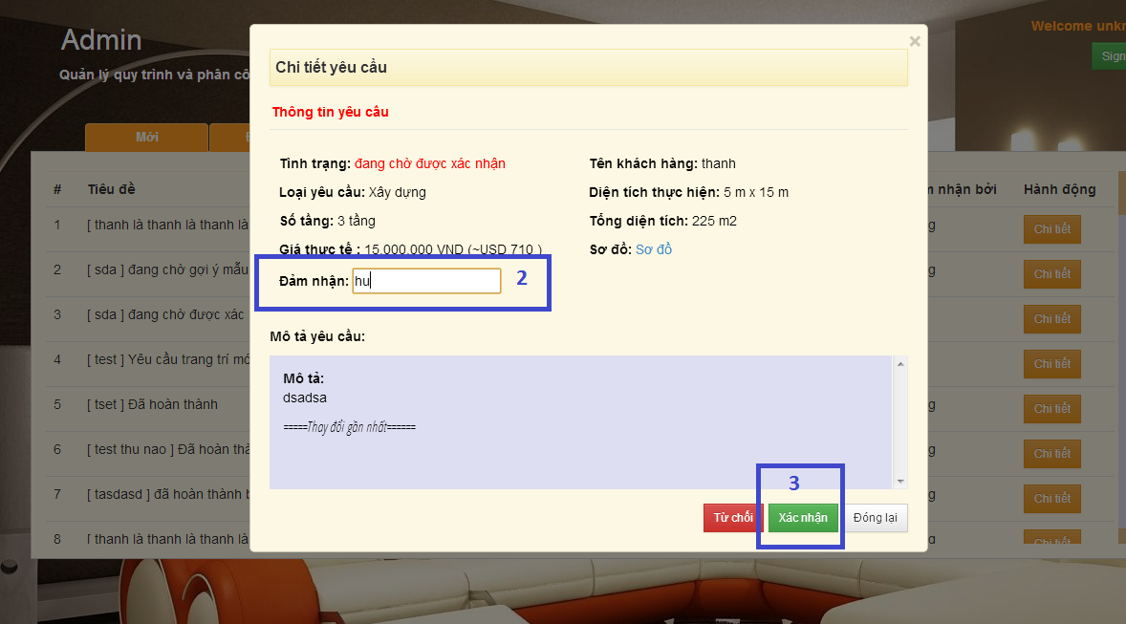

|  |  |
| --- | --- |
| **Step** | **Description** |
| 1 | In request list, click “Chi tiết” button |
| 2 | Fill box “Đảm nhận”  Select designer |
| 3 | Press button “Xác nhận” |

* + 1. **Confirm payment**



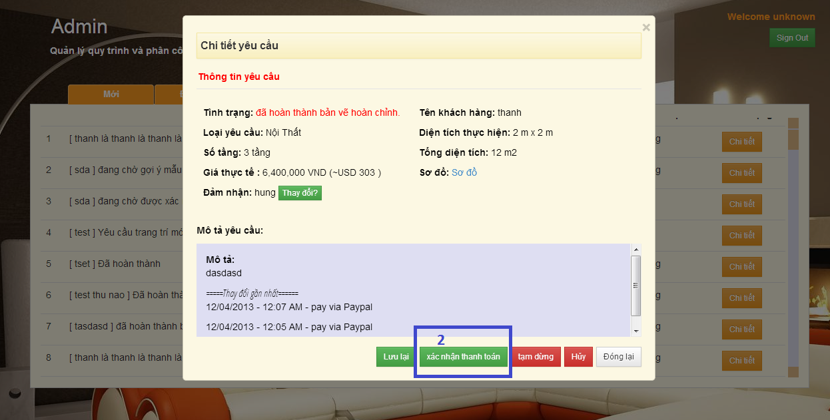

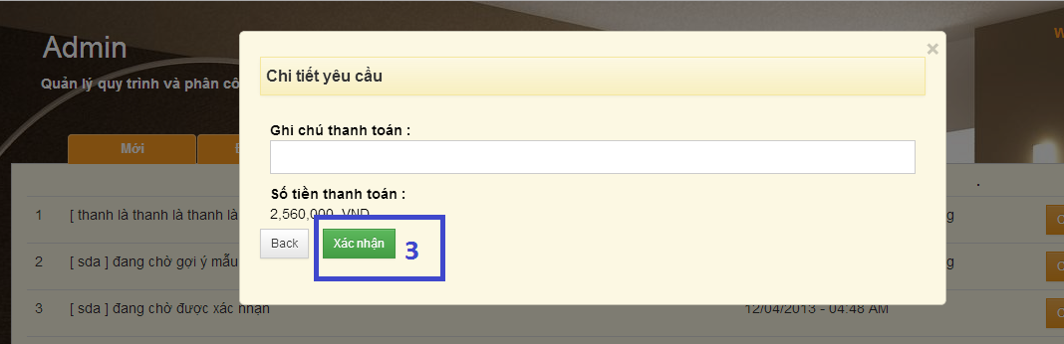

|  |  |
| --- | --- |
| **Step** | **Description** |
| 1 | Click “Chi tiết” button in request list |
| 2 | Click button “Xác nhận thanh toán” in request detail |
| 3 | Click to button “Xác nhận” |

### Designer

* + 1. **Login**

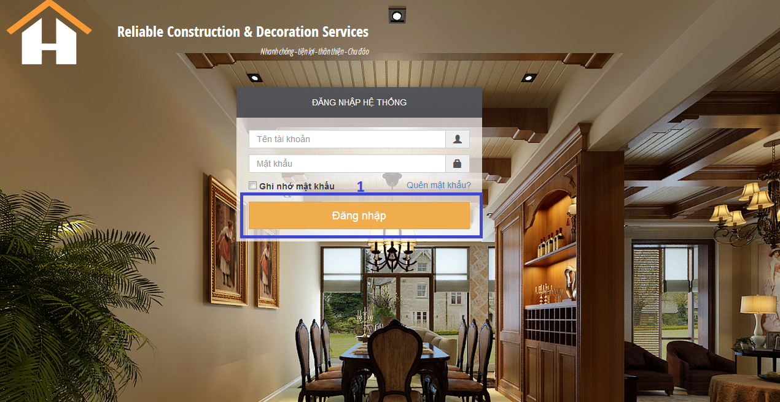

|  |  |
| --- | --- |
| **Step** | **Description** |
| 1 | Fill the username and password |
| 2 | Click button “Đăng nhập” to login |

* + 1. **View list of request**

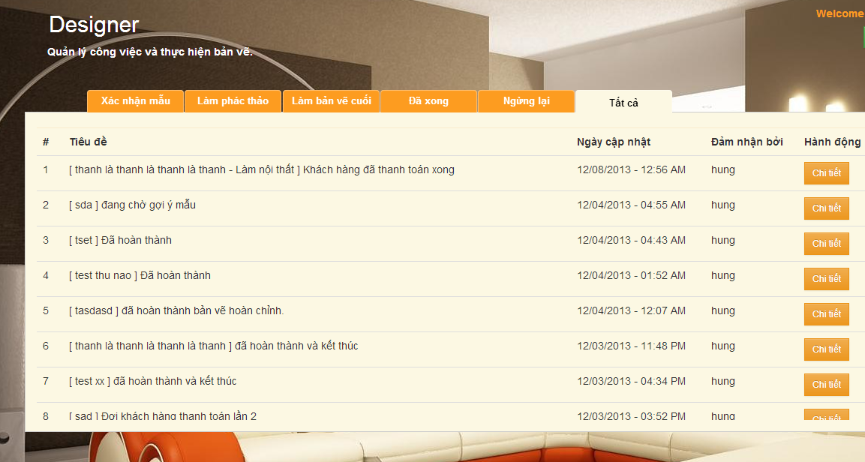

|  |  |
| --- | --- |
| **Step** | **Description** |
| 1 | Login to the system |
| 2 | View all processing request |

* + 1. **Suggest template**

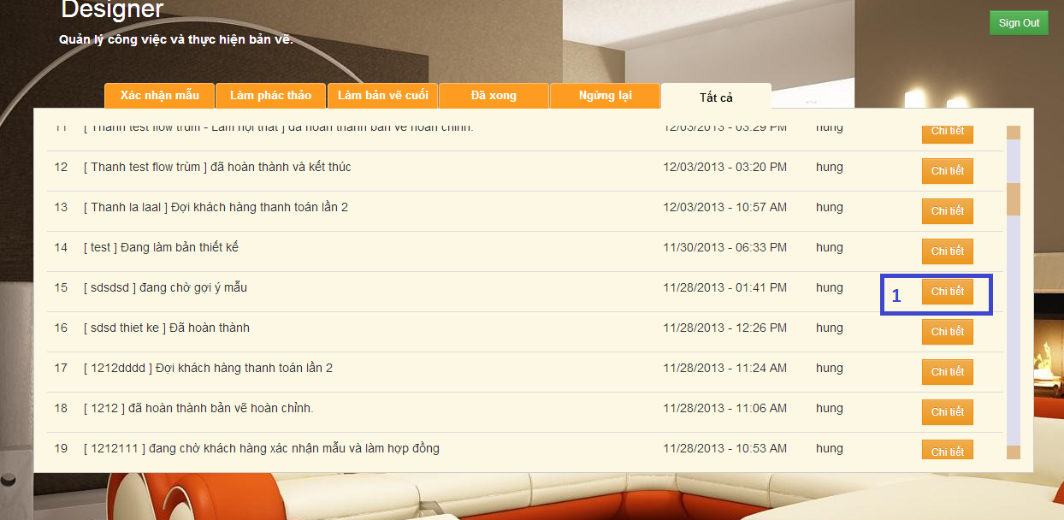

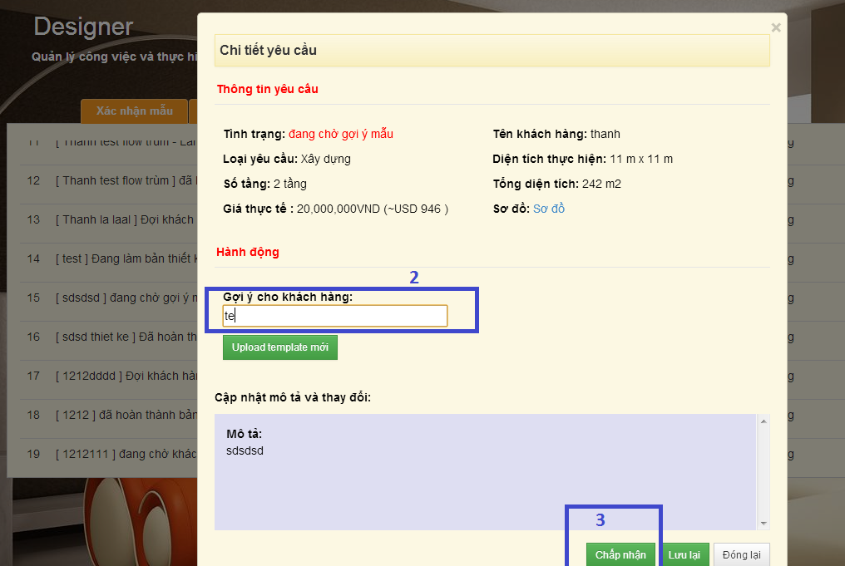

|  |  |
| --- | --- |
| **Step** | **Description** |
| 1 | Click “Chi tiết” button in request list |
| 2 | Fill box “gợi ý cho khách hàng” to select template |
| 3 | Click button “Chấp nhận” to confirm Done |

* + 1. **Upload new template**



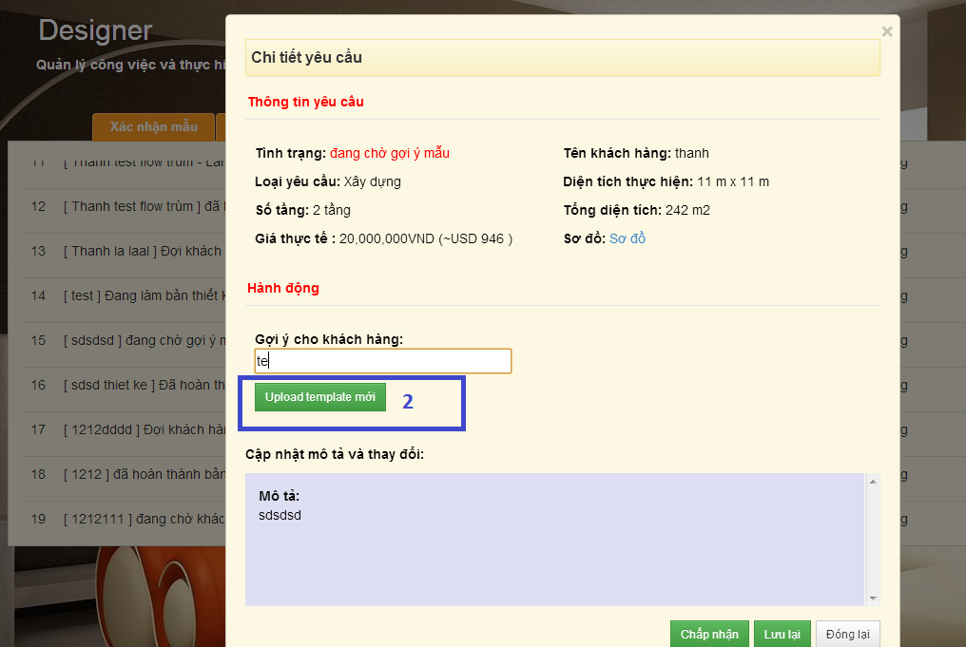

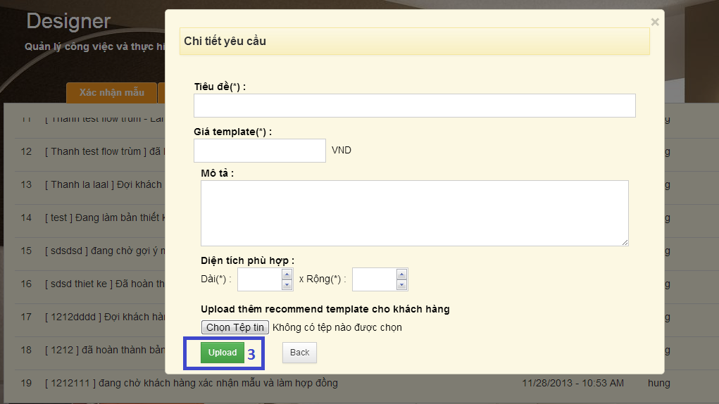

|  |  |
| --- | --- |
| **Step** | **Description** |
| 1 | Click “chi tiết” button in request list |
| 2 | Click button “upload template mới” |
| 3 | Fill form and click “Upload” button |

* + 1. **Upload 3D concept**

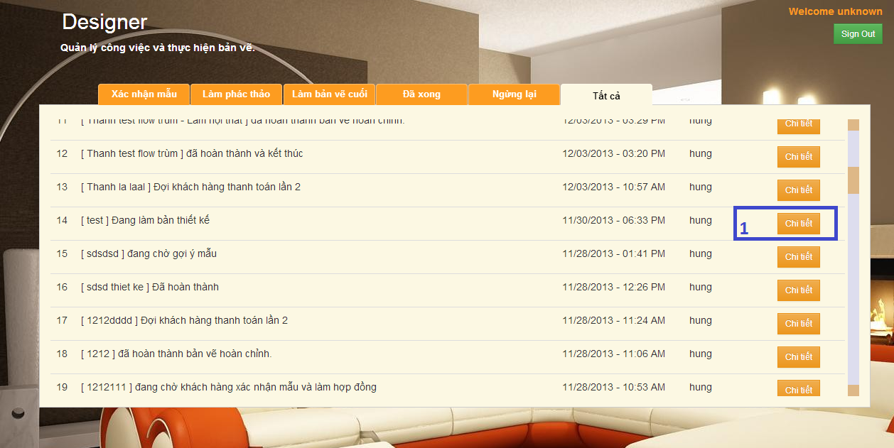

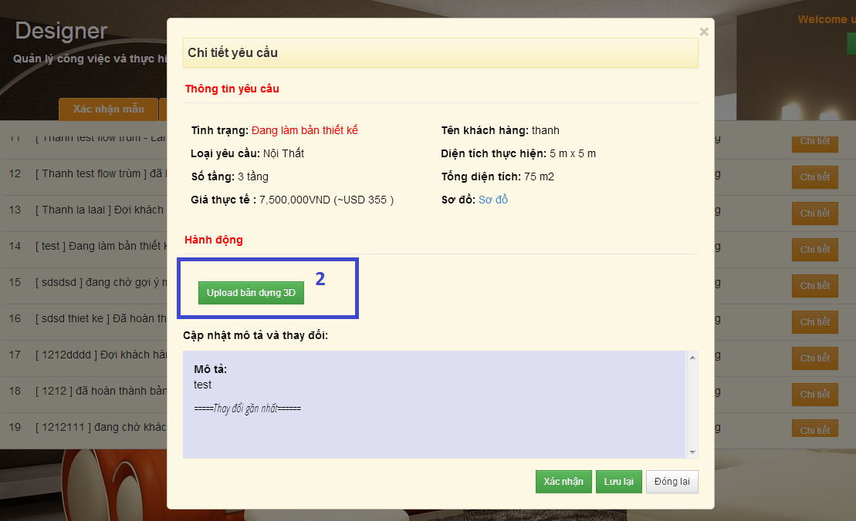

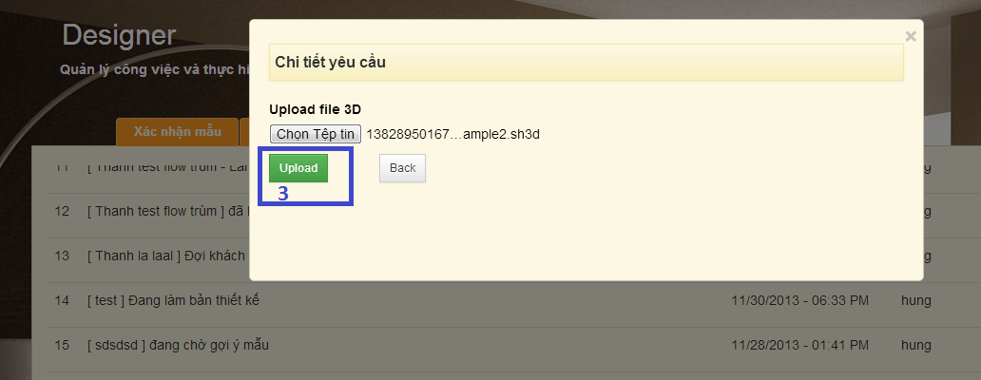

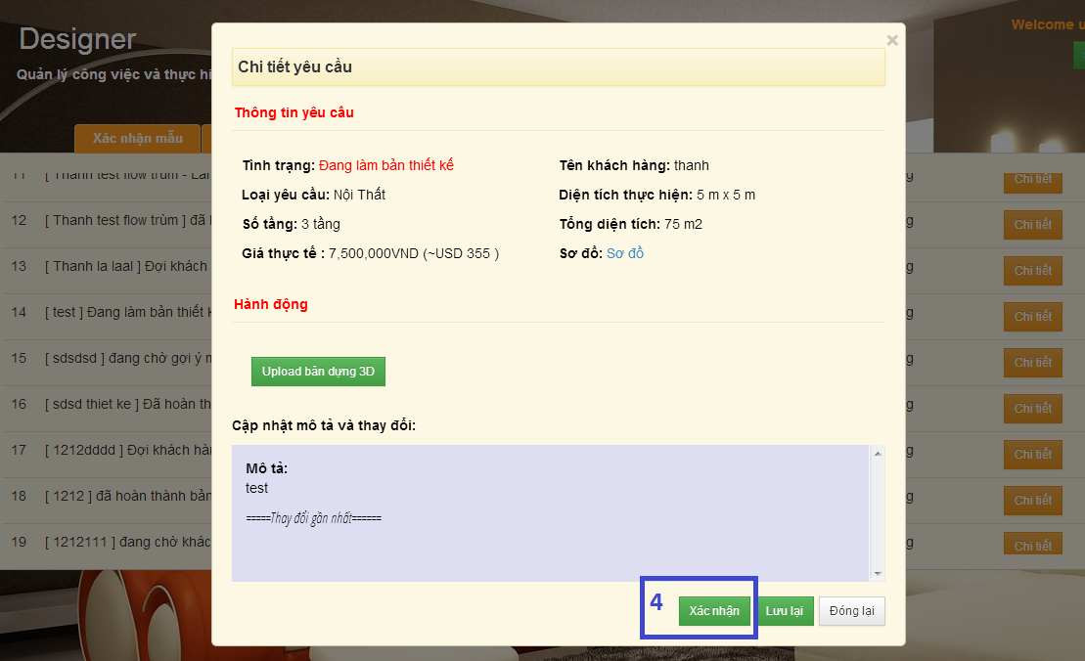

|  |  |
| --- | --- |
| **Step** | **Description** |
| 1 | Click to “chi tiết” button to view detail of request |
| 2 | Click button “Upload bản dựng 3D” |
| 3 | Choose file and click “upload” |
| 4 | Click “Xác nhận” to confirm the action is done |

* + 1. **Accept user modification**

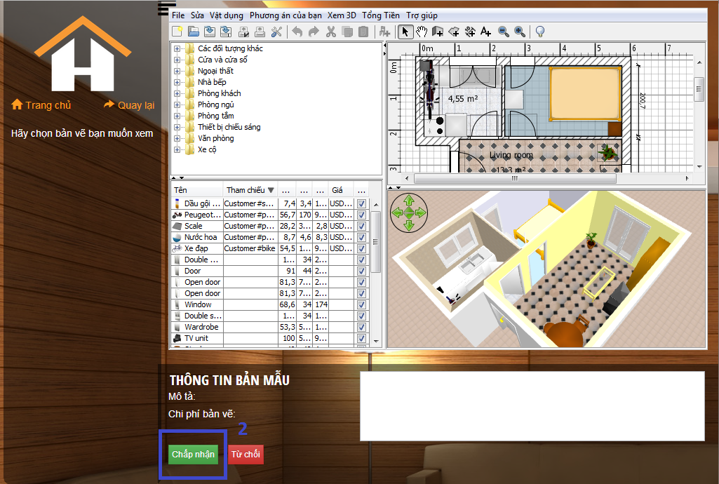

|  |  |
| --- | --- |
| **Step** | **Description** |
| 1 | View customer modification |
| 2 | Click to button “Chấp nhận” |

* + 1. **Reject user modification**

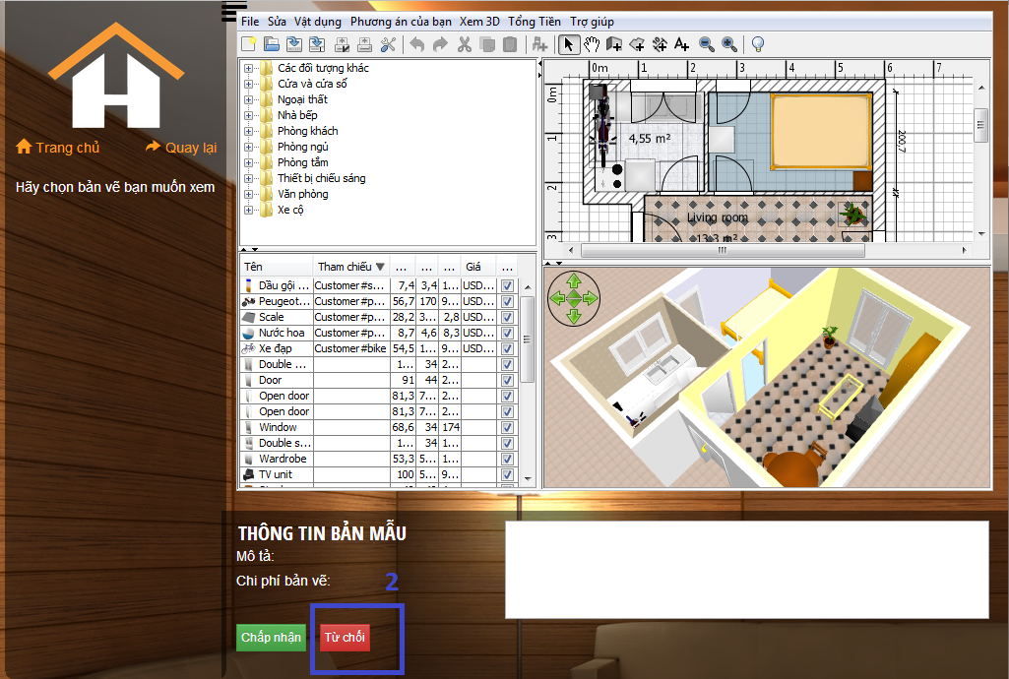

|  |  |
| --- | --- |
| **Step** | **Description** |
| 1 | View customer’s modification |
| 2 | Click to button “Từ chối” |

* + 1. **Confirm final drawing done.**



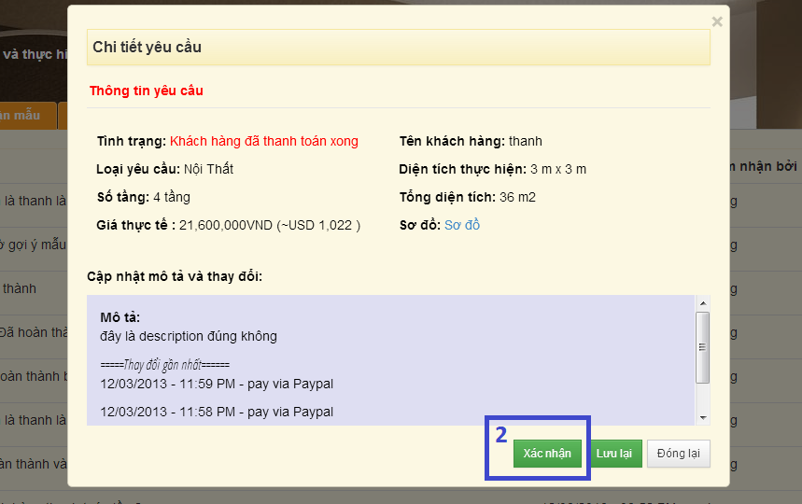

|  |  |
| --- | --- |
| **Step** | **Description** |
| 1 | Click to button “Chi tiết” to view request detail |
| 2 | Click button “Xác nhận” to confirm |

# Appendix

### 1/ Sweet home 3D framework:

### <http://www.sweethome3d.com/>